|  |
| --- |
|  |
| USER GUIDE FOR SR Devkit |
| Version 01.01.01 |

SR DEV KIT Version 4



**Revision History**

|  |  |  |  |
| --- | --- | --- | --- |
| **Version #** | **Remark** | **Date** | **Done By** |
| 01.01.01 | Initial Release | 11/22/2015 | Heer |
|  |  |  |  |
|  |  |  |  |
|  |  |  |  |
|  |  |  |  |
|  |  |  |  |
|  |  |  |  |
|  |  |  |  |
|  |  |  |  |
|  |  |  |  |
|  |  |  |  |
|  |  |  |  |
|  |  |  |  |
|  |  |  |  |
|  |  |  |  |
|  |  |  |  |

**Table of Contents**

1 Introduction 4

2 Definition(s) and Abbreviation(s) 5

3 Scope 6

4 Reference(s) 7

5 DEVKIT Overview 8

6 Basic Parts 9

7 Getting Started 11

8 Interface Information 12

8.1 Interface Support 12

8.1.1 Requisite for programming of NS-BLE & BLE/A module 13

8.1.2 Interface Board Detail 14

8.1.3 Motor Interface with Function Board (Pre-Configured) 15

8.1.4 Solenoid Interface with Board (Pre-Configured) 16

8.1.5 Relay 1(momentary) Control Interface (Lights are Pre-Connected) 17

8.2 Relay 2 (Maintained) Control Interface (Lights are Pre-Configured) 18

8.2.1 Temperature Interface 19

8.2.2 Constant Voltage LED Support (Pre-Configured) 20

1.2. Constant Current LED Support (No demo product on board) 21

8.2.3 Accelerometer Interface (Pre-Configured) 23

8.2.4 Factory Reset switch Interface. 25

8.2.5 Motion Detector Interface. (Pre-Configured) 26

8.2.6 Status Switch Interface (Pre-Configured) 28

8.2.7 Battery Voltage monitoring 29

8.2.8 Power Supply Interface 30

8.2.9 External peripheral connection 31

8.2.10 Water sensor interface (Pre-configured) 32

8.2.11 Humidity Sensor 33

9 Download SR Smart App for iOS 34

9.1 Download the SR Smart App through Apple Store 34

10 Download SR Smart app for Android 36

10.1 Download the SR Smart App through Play Store 36

11 Register and Operate SR Devkit 38

11.1 Register Device using Scan “QR Code” 38

11.2 Register Device manually 39

12 Operate SR Devkit using SR Smart App 41

12.1 Operation Modes 42

12.1.1 Local Operation Mode 42

12.1.2 Remote Operation Mode 42

12.1.3 Authorization Mode 42

13 Firmware Upgrade (OTA) 43

14 SR Portal 44

14.1 Sign-In Page 44

14.2 Secure Home Page 45

14.3 Add SR device 46

14.4 All SR Devices 47

14.5 Invite a New User Device 48

14.6 All Users 50

14.7 Audit Logs 51

14.8 Register SR Bridge 52

14.9 Configure SR Bridge 53

14.10 Dashboard Option 56

14.11 Invites Option 57

14.12 Enable Push Notification 58

15 Jumper Details 59

16 LED Indication Detail (All LED’s are Pre-Configured) 61

17 Accessory details connected to dev kit 63

18 GPIO Information for Interface 64

19 Disclaimers /Contacts/FCC 65

20 Electric Characteristics 66

# Introduction

The SecuRemote Development Kit is designed to exemplify the capabilities of the module operating in the direct or local mode.

The com board module is preloaded with basic instruction code to drive various devices connected to the function board.

The development kit requires an application to operate. This application is an example of basic electro-mechanical interfaces. The module features 20 i/o’s. These i/o’s are currently configured to operate the devices on this kit. This i/o’s can be configured to operate in many different ways, depending upon the specific product requirements.

SecuRemote features product-ready software and hardware platforms to fast forward your product development while reducing risk and costs.

# Definition(s) and Abbreviation(s)

|  |  |
| --- | --- |
| **Name** | **Abbreviation** |
| CB | Communication board or Com board |
| FB | Function board |
| i/o | Input / Output. These operate as basic switches (output) and/or monitoring various conditions. (Input). They can also provide limited power for sensors. (General Purpose) |
| OTA | Over The Air. A method used to update software without direct cable interface |
| Dev | Developer Kit complete |
| DOT | a (dot) b = a x b x cos(theta). Angular calculation including velocity. |
| GPIO | General Purpose Input Output. |
| BLE | Bluetooth Low Energy |
| SRP | SecuRemote Online Portal <http://www.securemoteonline.com> |
| Local or Direct mode | Refers to a Smartphone operating the SR chipset directly. Phone to Device |
| Authorization mode | Refers to a Smartphone operating the SR chipset directly. Phone to Device but also adds control through data services to SRP server. |

# Scope

The SRDEV3 includes all functionality of the previous versions. The SRDEV3 can operate as a standalone platform as shown is Kits Overview SRDEV2 or can be switched over to an ‘authorization” mode. The authorization mode allows added protection by requesting an “authorization” code before operating the developer kit. For clarity the authorization function only operates the relays. The other device(s) / functions such as temperature and so on are not programmed to be controlled with an “authorization” scheme.

As shown in the Kits Overview the SRDEV3 does allow an added layer of control. The basic SR function allows to control use of the device by first requesting an authorization code when attempting to operate the device (developer kit relays in this case). This authorization also extends to users through the use of an “invite” code. The administrator remains the control point.

The SR architecture also allows Indirect/ Remote control through either through a Switch / Gateway or cellular. (Kits Model(s): SRDEV4 and SRDEV5). This type of Indirect / Remote control is capable of scheduling open/close times, number of accesses and so on.

# Reference(s)

|  |  |
| --- | --- |
| **Version #** | **Title** |
| Version 01.03.15 | USER GUIDE FOR NS-BLE & A BLE MODULE |
|  |  |
|  |  |

# DEVKIT Overview

# Basic Parts

BLUE LED >BLE CONNECTED

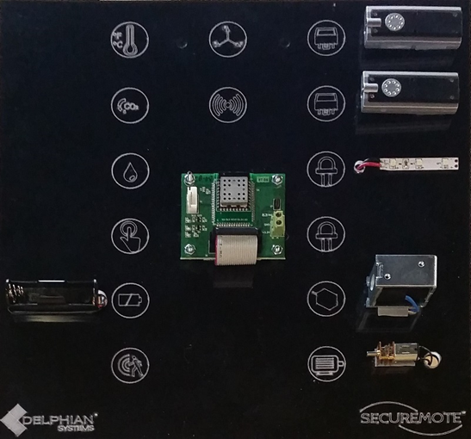

Relay LED indicator

Relay LED indicator

LED CV indicator

GREEN LED >FUNCTION OK

RED LED >POWER OK

Solenoid

Motor

Battery Voltage Check

Motion Sensor

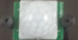

Delphian module with EMI shielding

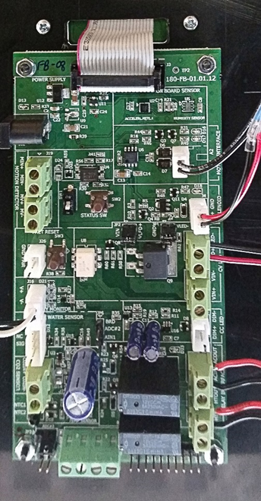

Humidity Sensor

Status Button 1

Status Button 2

Temperature Sensor

Alternate power out

FUNCTION Board Rear View (cropped and close up)

COM Board Front view (12” x 12”)

Power Supply (IN: 110 Volt 60 Hz, A/C. OUT: 12 Volts DC.5.5mm x2.1mm plug)

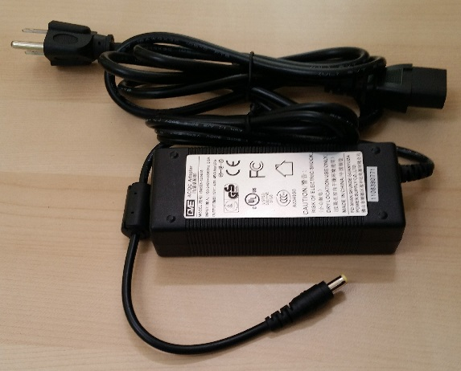

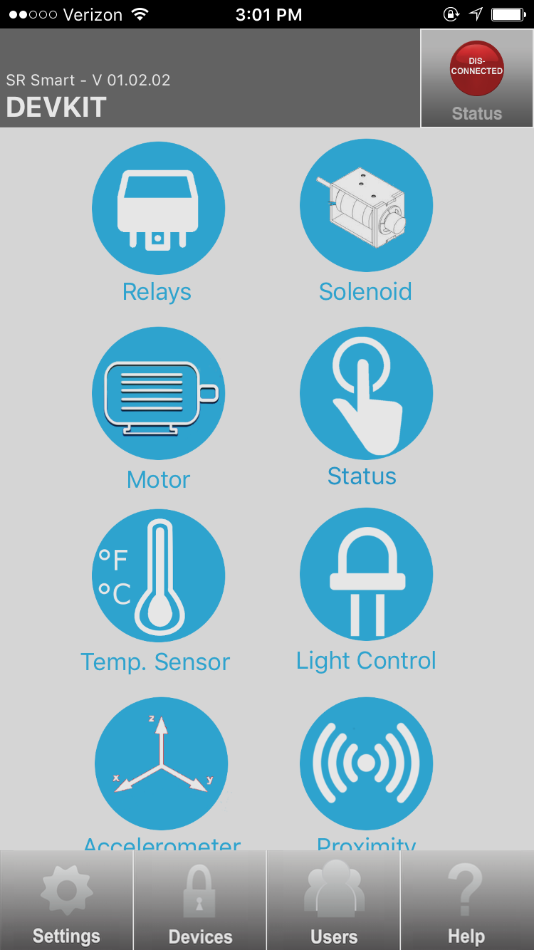Mobile application home screen:

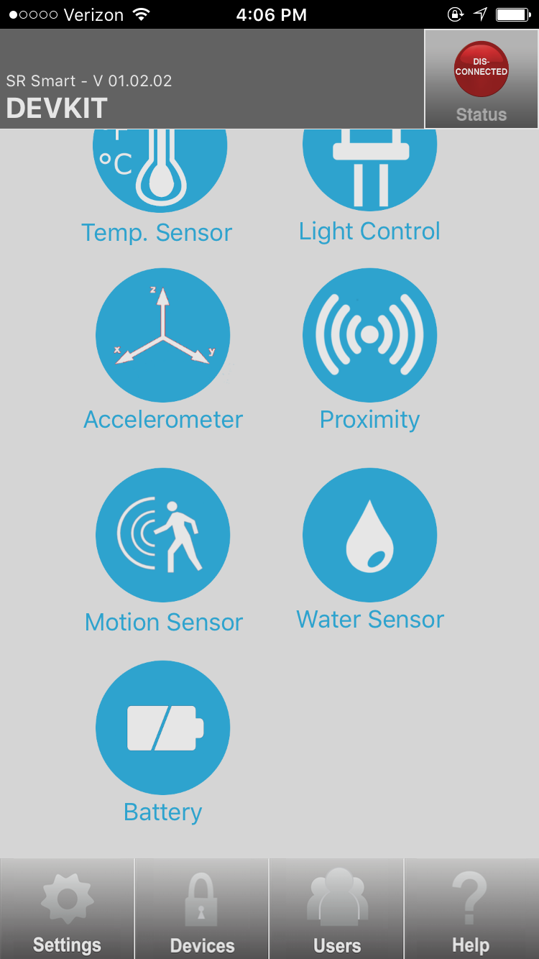

Stand for holding developer board(s)

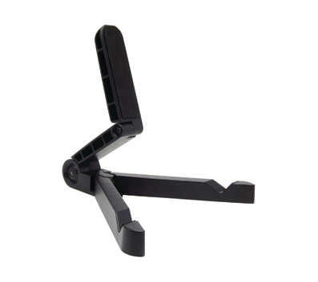

# Getting Started

1. Download application for Smartphone (please refer section 17 for more detail)
2. Plug in Power supply to Dev Kit receptacle #20

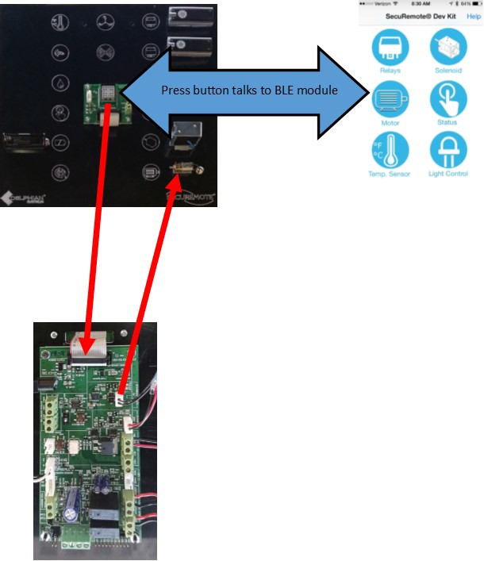

# Interface Information

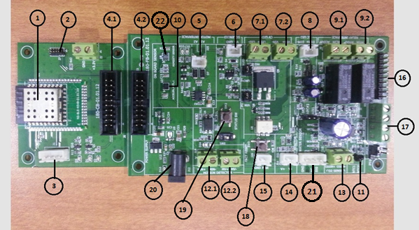

**Dev kit Function board i/o’s**

## Interface Support

1. NS-BLE Module or A BLE Module
2. Programming Interface connector
3. UART Debug Interface connector
4. CB-FB Interface connector
5. Motor Interface
6. Solenoid Interface
7. Constant voltage LED support

7.1:- LED fixture connection

7.2:- External supply for LED fixture

1. Constant current LED support
2. Relay Interface

9.1 Relay2

9.2 Relay1

1. Accelerometer
2. Temperature
3. Motion sensor

12.1:-Motion sensor input

12.2:- Motion sensor supply

1. CO2 sensor
2. External battery monitoring
3. External switch connector
4. External peripheral Interface
5. External supply connector
6. Status Switch1
7. Status Switch2
8. Power supply adapter connector
9. Water sensor connector
10. Humidity Sensor

### Requisite for programming of NS-BLE & BLE/A module

The module features two methods of programming, OTA and via cable. The OTA allows field updates of the operational code. For cable programming a J-Link LITE CortexM device is required to adjust the program in the module (Pictured below). The module is pre-programmed to operate the devices on the board. No adjustments are required.

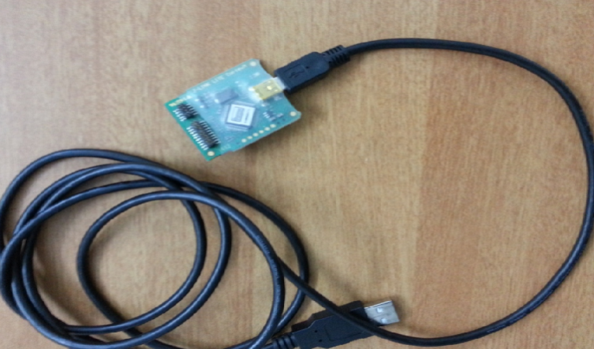

**Figure 1: JTAG programming USB cable**

### Interface Board Detail

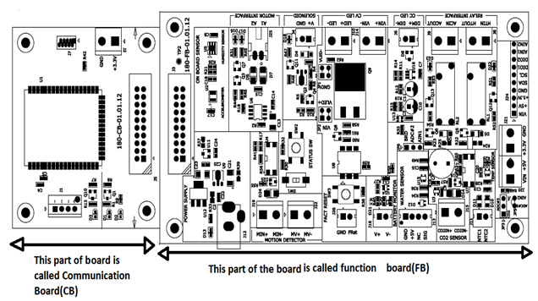

**Combined Board Details**

### Motor Interface with Function Board (Pre-Configured)

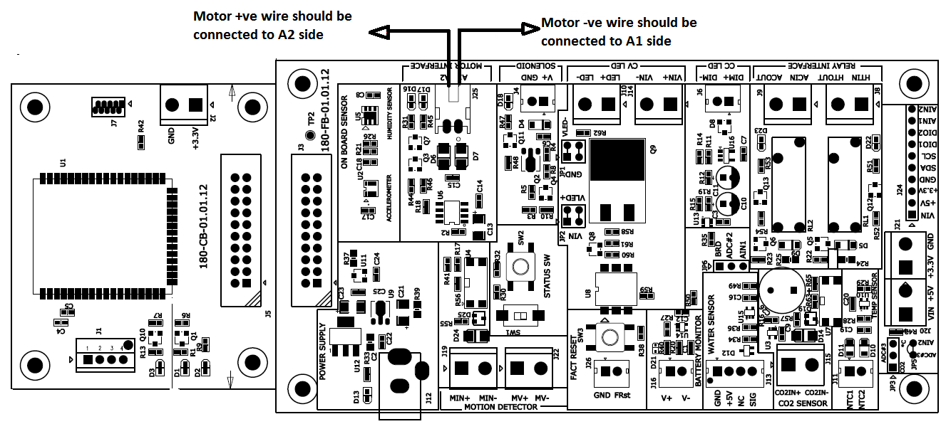

**Motor connection with FB**

- Motor is interfaced with FB which is connected through 2 wire connectors.

- "+Ve" wire of motor is connected to A2 of FB and "-Ve" wire of Motor is connected to A1 of FB.

- When user presses on “FORWARD” button from SecuRemote dev kit application the motor will rotate forward and if the user presses on “REVERSE” button from SecuRemote dev kit application the motor will rotate reverse. The motor will run for 1 – 2 seconds in each direction.

- If connection is reversed the motor will rotate reverse.

### Solenoid Interface with Board (Pre-Configured)

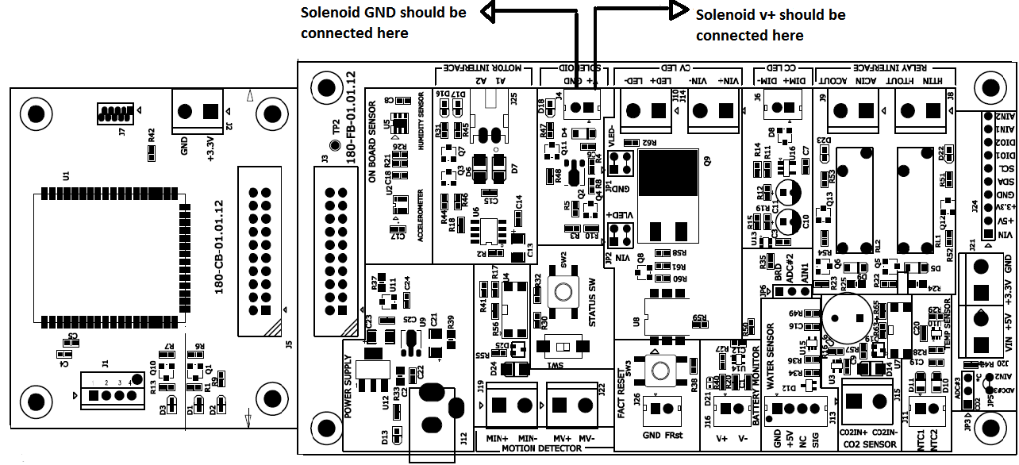

**Solenoid connection with FB**

- Above diagram marked with arrow shows the solenoid connection with FB. One wire of solenoid is connected to V+ of FB and other wire of solenoid is connected to GND of FB.

- When user press on “OPERATE” button from SecuRemote dev kit application then solenoid will ON for 3 seconds.

No polarity for solenoid is required.

### Relay 1(momentary) Control Interface (Lights are Pre-Connected)

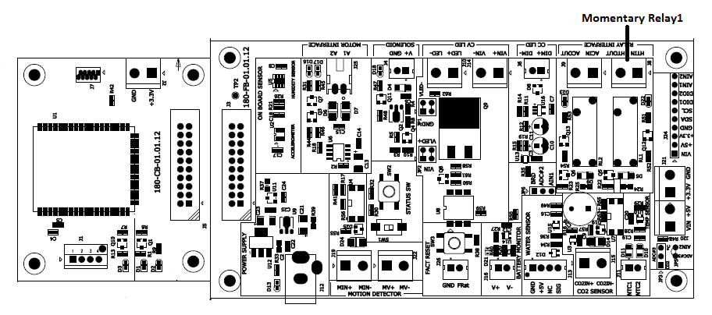

**Relay 1 control interface with Board**

- When user presses the momentary “PRESS” button from SecuRemote dev kit application the momentary relay 1 will stay ON for 2 seconds after that the relay will be turned OFF.



## Relay 2 (Maintained) Control Interface (Lights are Pre-Configured)

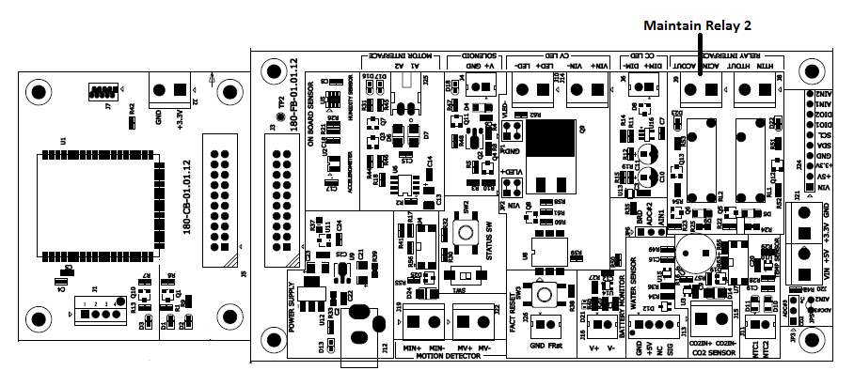

**Relay 2 control interface with Board**

-When user presses the maintained “PUSH” button from SecuRemote dev kit application the Maintain relay 2 will stay “ON” and turns off after “RELEASE” button is pressed from SecuRemote dev kit application.

Note: the small indicator LED lights are battery powered. Failure to turn OFF the relay will drain battery.



### Temperature Interface

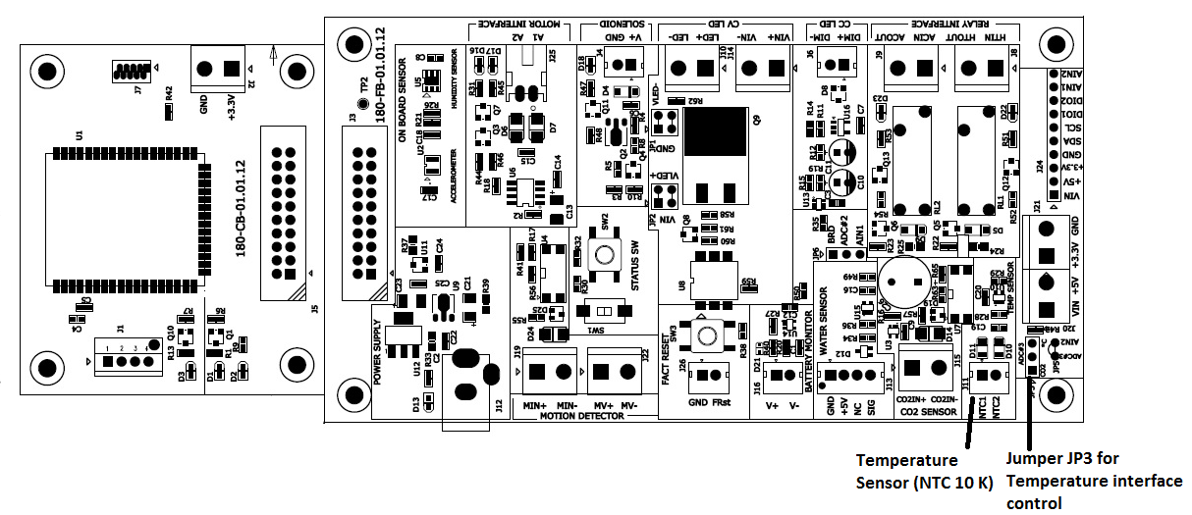

**Jumper interfaces for Temperature**

- Temperature sensor (NTC 10K) is placed on FB.

- SecuRemote dev kit application shows temperature in °C (Celsius) and °F (Fahrenheit) on temp. Sensor screen.

**Jumper setting for Temperature:-**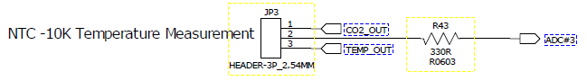

**Jumper pin setting for Temperature**

**Note:-**

1. Connect 2 pin jumpers on Pin#2 and Pin#3 of jumper JP3 for temperature interface control.

### Constant Voltage LED Support (Pre-Configured)

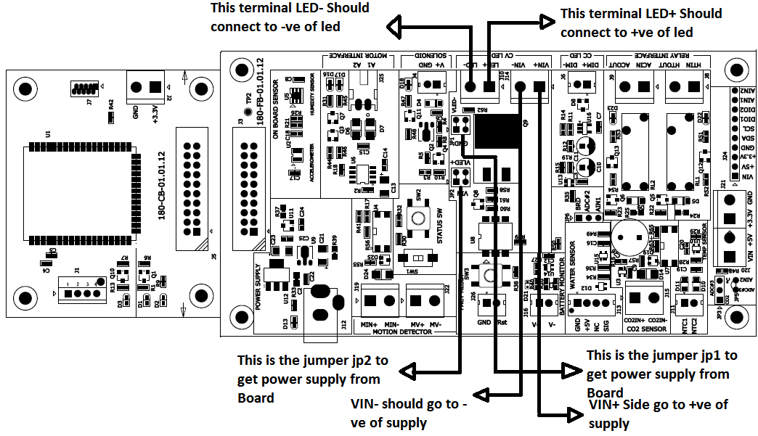

**Constant Voltage LED support**

* Use Jumper JP1 and JP2 to use on-board power supply of +12VDC for LED fixture.
* "+Ve" wire of LED fixture is connected to LED+ of FB and "-Ve" wire of LED fixture is connected to LED- of FB.
* User can slide the sliding bar to change intensity of LED fixture from Light control screen of SecuRemote dev kit application.

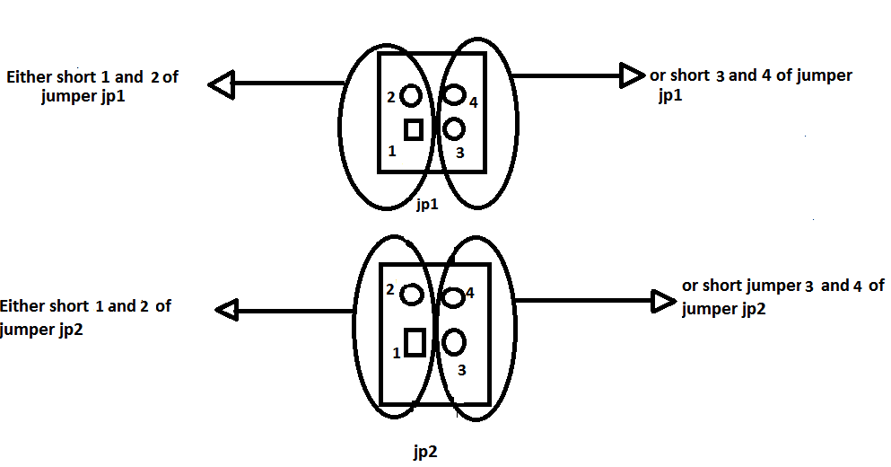**- Jumper setting for on-board supply (12VDC):-**

**Jumper setting of jp1 and jp2**

* It is shown that either pin#1 & pin# 2 should be connected for JP1 or pin# 3&pin# 4.
* Similarly for jp2 either pin#1 & pin# 2 or pin# 3 & pin# 4 should be connected.
* To use external supply for LED fixture, "+Ve" wire of supply is connected to VIN+ of FB and "-Ve" wire of supply is connected to VIN- of FB.

**Note: -**In case of external supply for LED fixture, the jumper connection for JP1 and JP2 are not required.

* 1. **Constant Current LED Support (No demo product on board)**

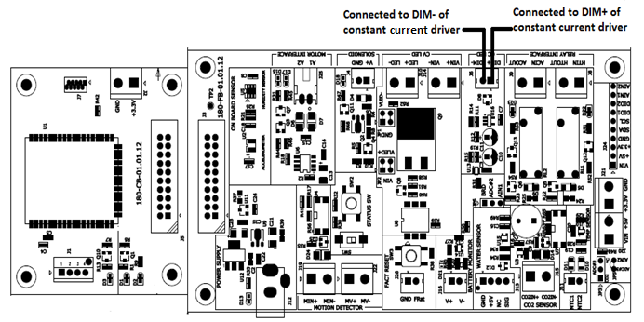

**Connection interface of Dimmer**

- Dim+ connection of dimmer driver must be connected to Dim+ terminal of FB board and Dim- connection of dimmer driver must be connected to Dim- terminal of FB board.

- LED fixture is driven through dimmer driver.

- User can slide the sliding bar to change intensity of LED fixture from Light control screen of SecuRemote dev kit application.

### acc.pngAccelerometer Interface (Pre-Configured)

**Position of accelerometer chip**

- Accelerometer chip is designed with a Triangle arrow which indicates the orientation of the board. Below figure explains thoroughly, on how to change the board orientation up, down, rotate 900 left and rotate 900right or change x, y, z direction of the board. In Normal Condition when Board is stable z=1, y=0, &x=0.

- In SecuRemote dev kit application, accelerometer screen shows reading of X, Y, Z directions according to dev kit orientation.

* Axis Information

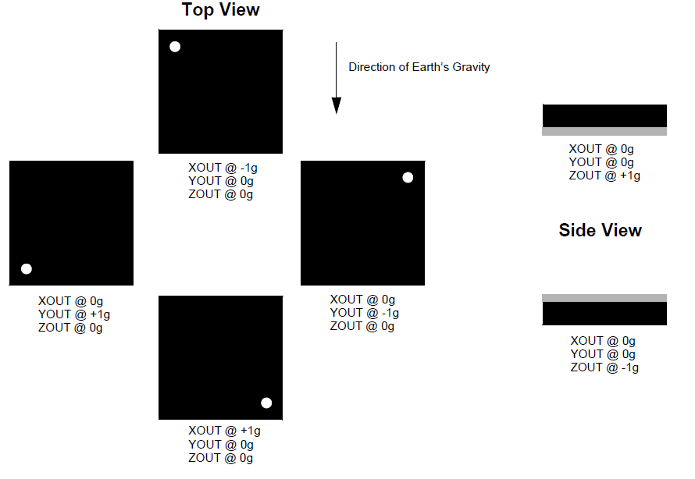

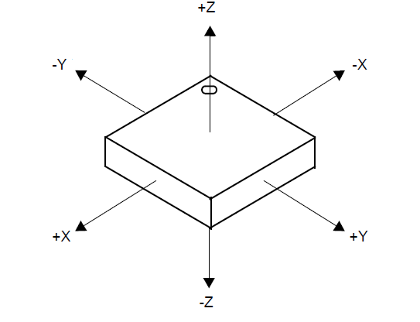**Dot orientation of Accelerometer chip**

### Factory Reset switch Interface.

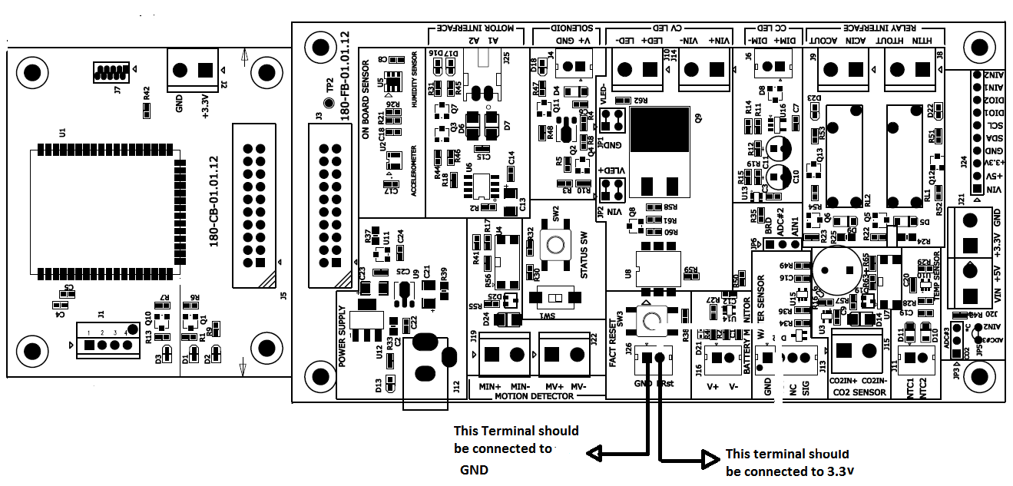

**Factory Reset switch interface**

- Factory reset switch SW3 is placed on FB.

- When user presses switch SW3, the SecuRemote dev kit application will show “Pressed” on status screen and when user releases the switch SW3, the SecuRemote dev kit application will show “Released” on status screen.

- A parallel switch can be connected at J26 connector. Please refer below figure for connection detail.

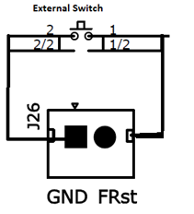

**Shows External switch interface with J26 connector**

### motion.pngMotion Detector Interface. (Pre-Configured)

**Motion sensor interface detail**

- Output of "+Ve" wire of motion sensor is connected to MIN+ of FB and "-Ve" wire of motion sensor is connected to MIN- of FB.

- When motion is detected then SecuRemote dev kit application will show motion detected icon on motion screen and if motion is not detected then SecuRemote dev kit application will show motion not detected icon on motion screen. The motion detector views the front of the board, not rear. Range is about 6 feet.

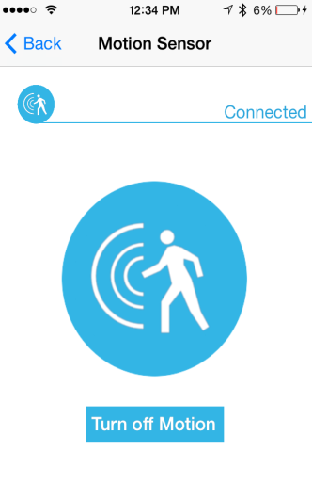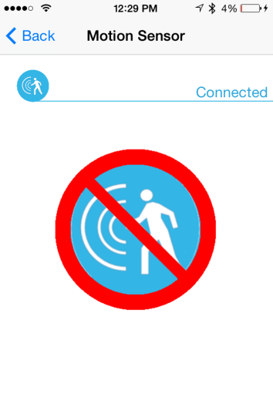

- To provide supply to motion sensor, connect MV+ of FB to DC- input of motion sensor and connect MV- of FB to GND of motion sensor. Please refer below figure for details.

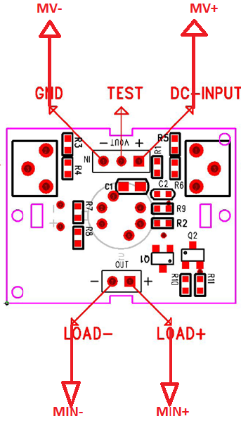

**Motion sensor connection pin with FB**

### Status Switch Interface (Pre-Configured)

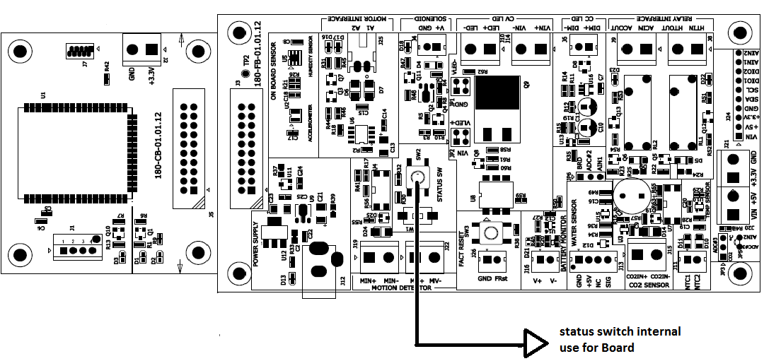

**Status Switch Interface**

- Status switch SW2 is placed on FB.

- When user presses switch SW2, the SecuRemote Smartphone application will show “Pressed” on status screen and when user releases switch application will show “Released” on status screen.

### Battery Voltage monitoring

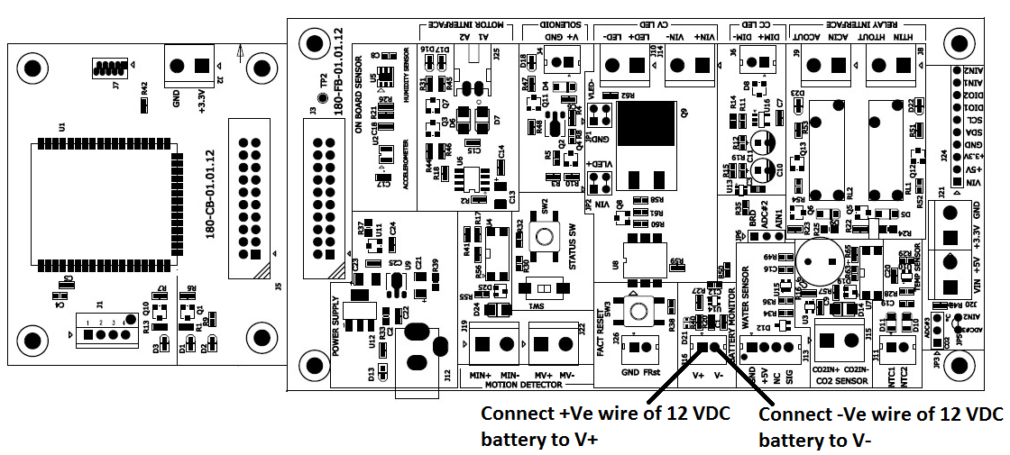

* SecuRemote dev kit application will show current level of battery (supported range is 12 VDC maximum) on battery monitor screen.
* Connect +Ve wire of battery to V+ of J16 connector of FB and connect –Ve wire of battery to V- of J16 connector of FB.

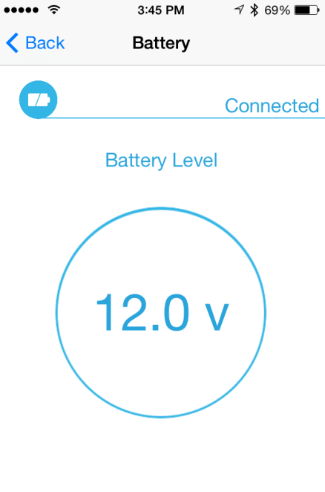

### Power Supply Interface

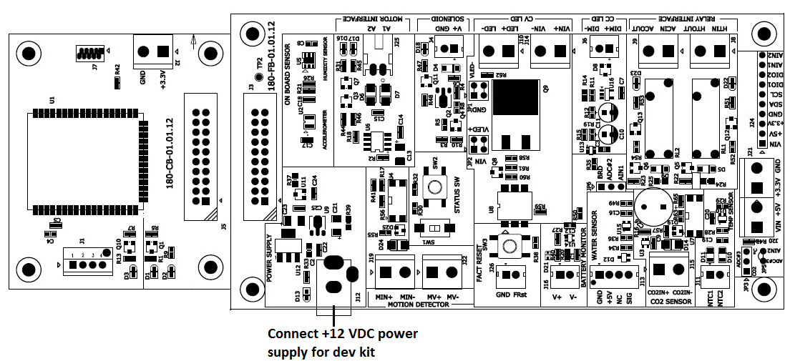

**Power Supply Interface**

- 12VDC/2000mA power supply adapter is connected to J12 connector of FB to provide the supply to CB-FB board. This power is used for Dev kit to drive lights etc. If required, power may be customized. Plug - 5.5mm X 2.1 mm.

### External peripheral connection

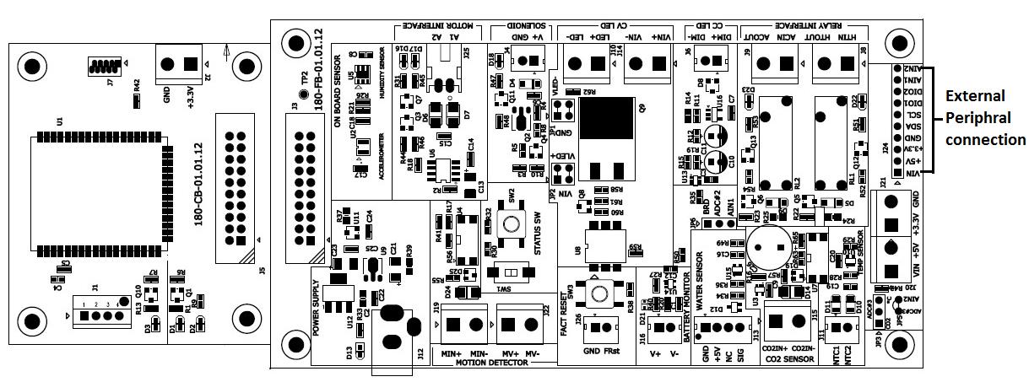

**External peripheral connection**

- External peripheral connections with two analog output pins, two Digital output pins, and SCL, SDA, GND, + 3.3V, VIN (12VDC) supply are supplied for customer use. Max current - 200 mA.

### Water sensor interface (Pre-configured)

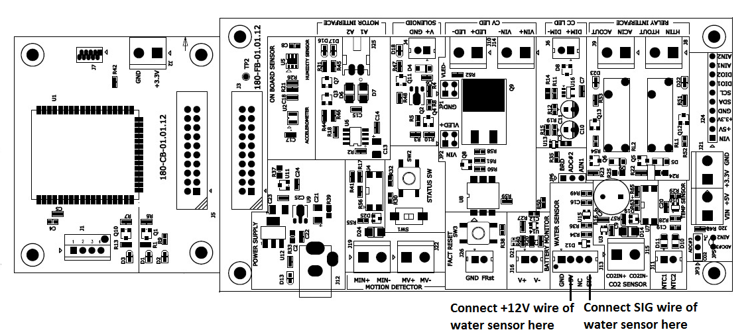

- When water is detected then SecuRemote dev kit application will show “DETECTED” on water sensor screen and if water is not detected then SecuRemote dev kit application will show “NOT DETECTED” on water sensor screen.

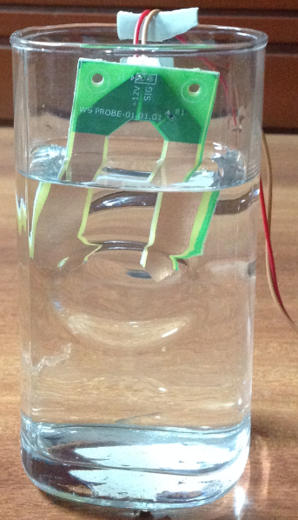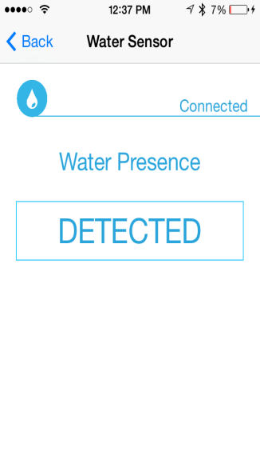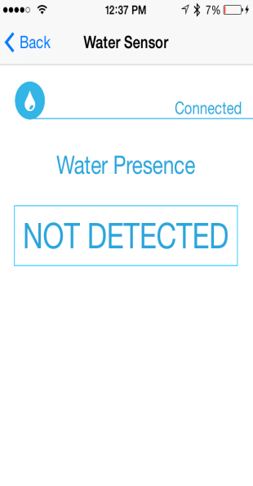

### Humidity Sensor

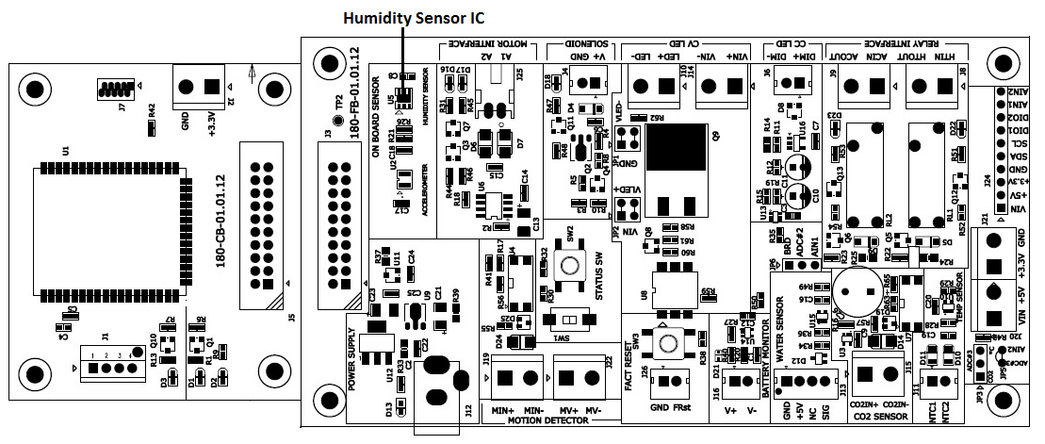

- In SecuRemote dev kit application, Humidity sensor screen shows reading of humidity in RH.

- Humidity sensor IC has 0 to 100 % RH operating range.

**Note: -**SecuRemote dev kit mobile app only shows humidity sensor icon if humidity sensor IC is mounted on FB.

# Download SR Smart App for iOS

The SR Smart App will operate any SR device. Upon selecting the SR device user wants to operate the app will automatically display menu features and functionality for the selected device. The app is available for download through the App Store on your Smartphone. Search for "SecuRemote" or "SR Smart" or “SecuRemote® Smart” word. The user should always download the SR Smart App directly from your smartphone’s store as this practice ensures future automatic app improvements/updates.

***Note:*** Data Services must be turned on in Settings before accessing the App Store.

## Download the SR Smart App through Apple Store

1. Click on “App Store” Icon to open app store.
2. Search “securemote” keyword to find SecuRemote® Smart application.
3. Click on “GET” it will prompt for an Apple ID and password to begin SR Smart application download.

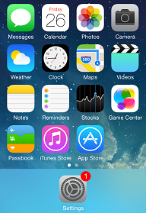 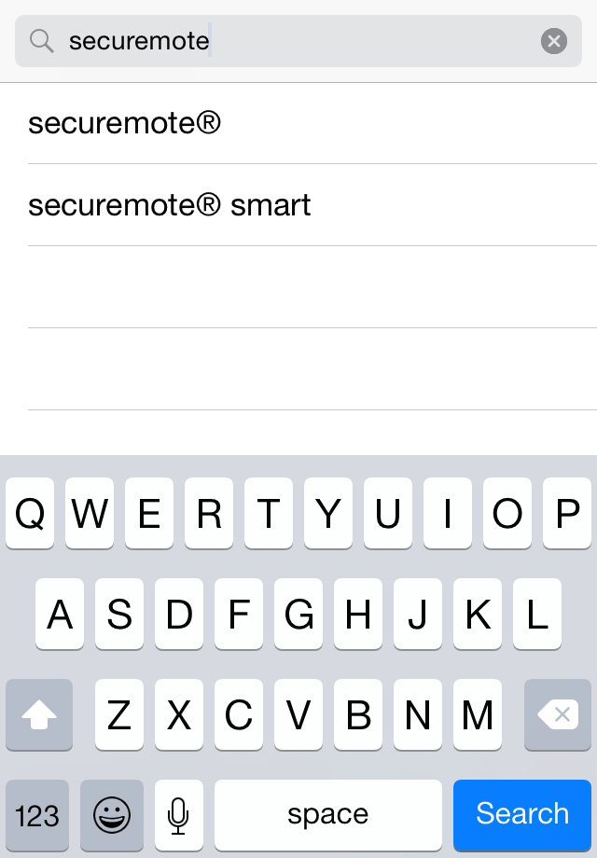 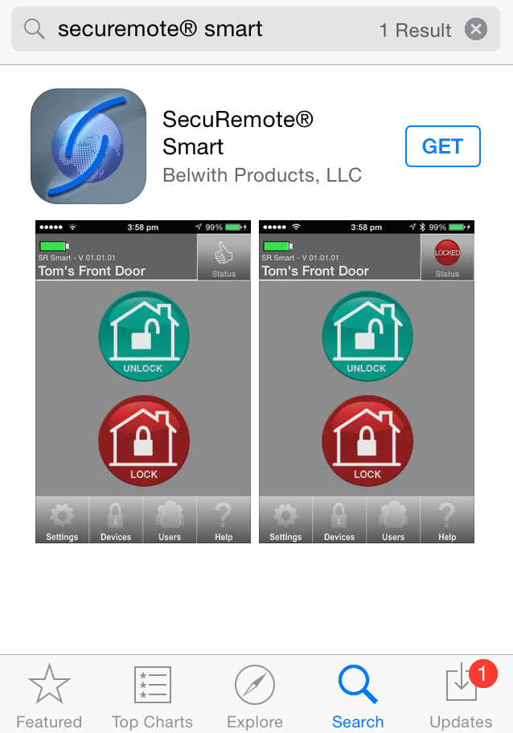

Smartphone Home Screen Search for SR Smart App App store search Screen

1. Click on “INSTALL”, to start installation of SR Smart application.
2. By default, the “SR Smart” App icon will be placed in the first available spot on your home screen.

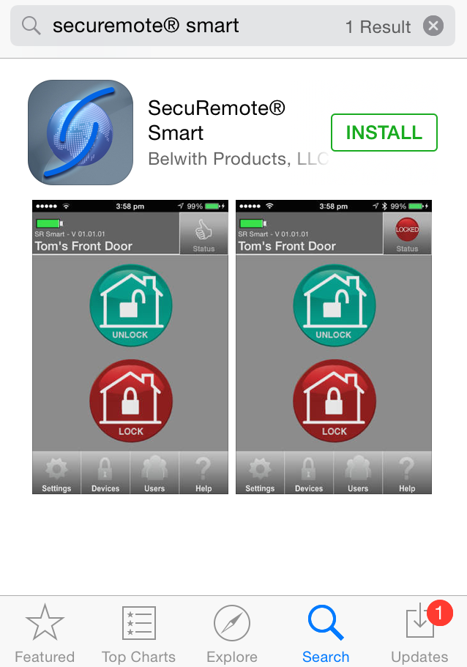 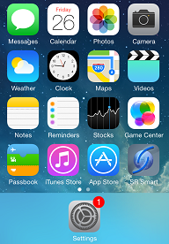

Installation Screen  App Icon in Home Screen

# 

# Download SR Smart app for Android

The SR Smart App will operate any SR device. Upon selecting the SR device user wants to operate the app will automatically display menu features and functionality for the selected device. The app is available for download through the Google Play Store on your Smartphone. Search for "SecuRemote" or "SR Smart" or “SecuRemote® Smart” word. The user should always download the SR Smart App directly from your smartphone store as this practice ensures future automatic app improvements/updates.

***Note:*** Data Services must be turned on in Settings before accessing the App Store.

## Download the SR Smart App through Play Store

1. Click on “Play Store” icon to download SR Smart App.
2. Search “securemote” keyword to find SR Smart application.
3. Click on “FREE” to begin SR Smart application download.

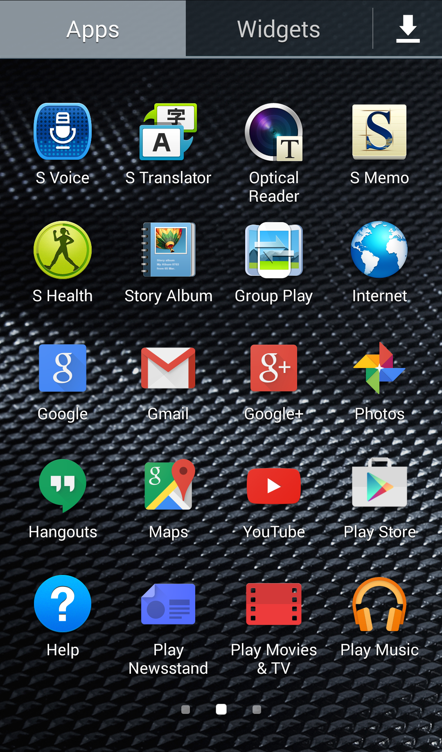 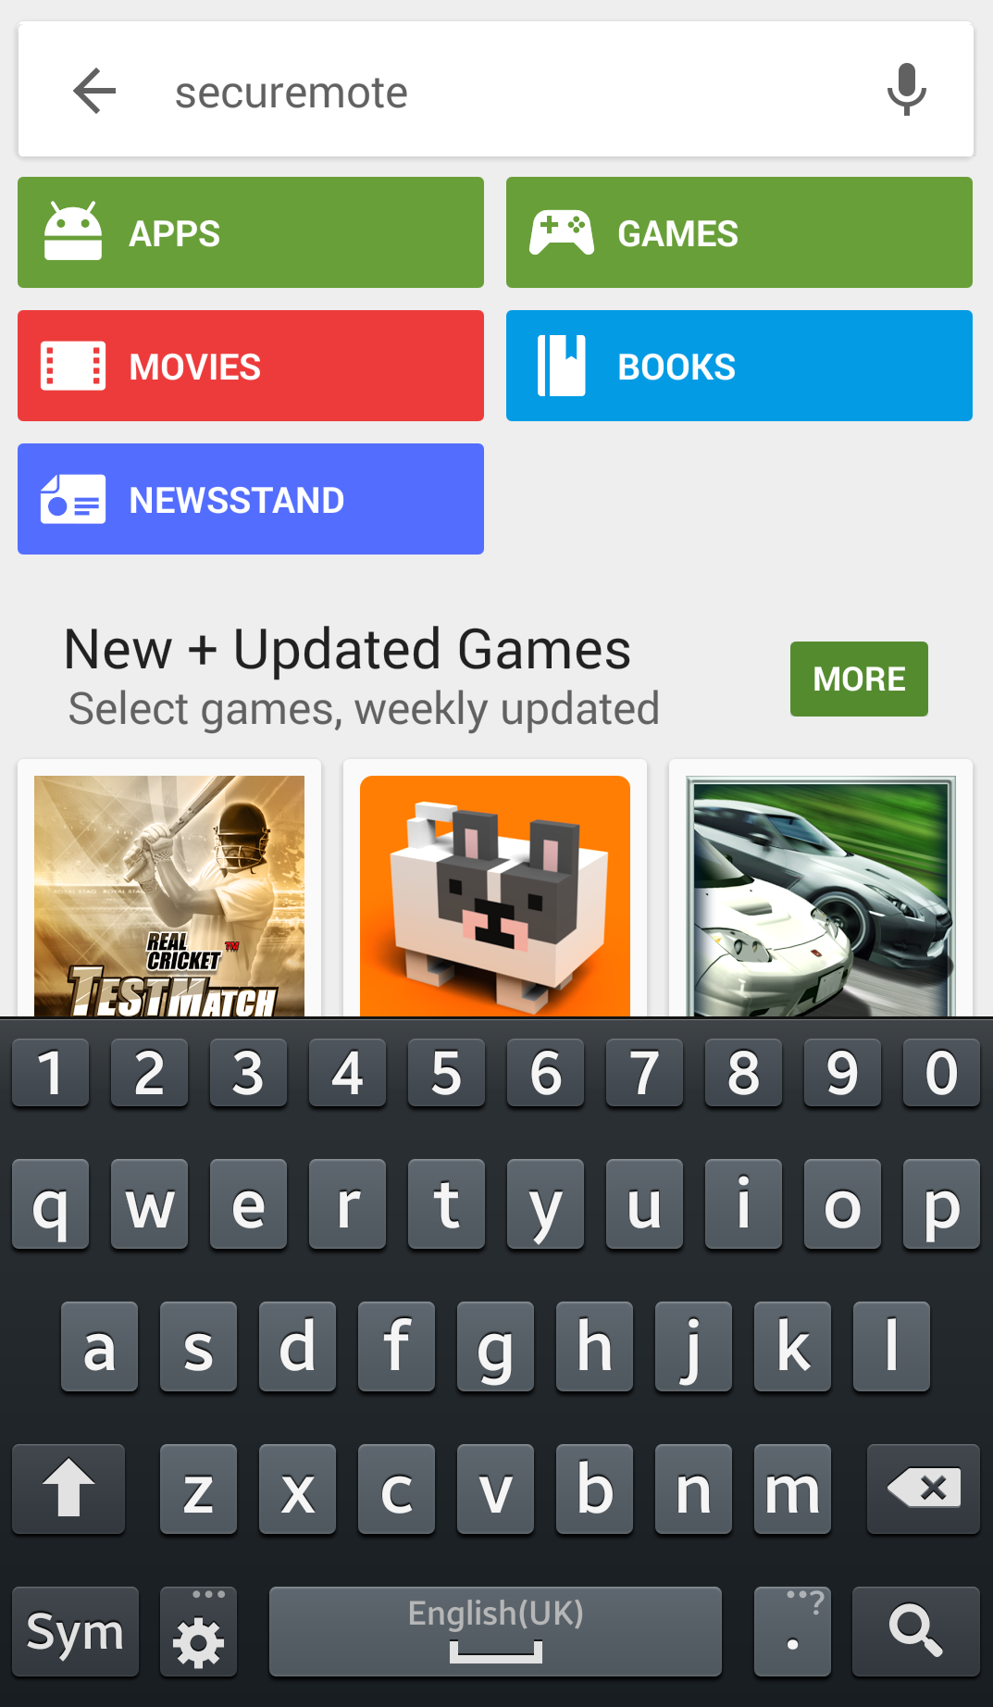 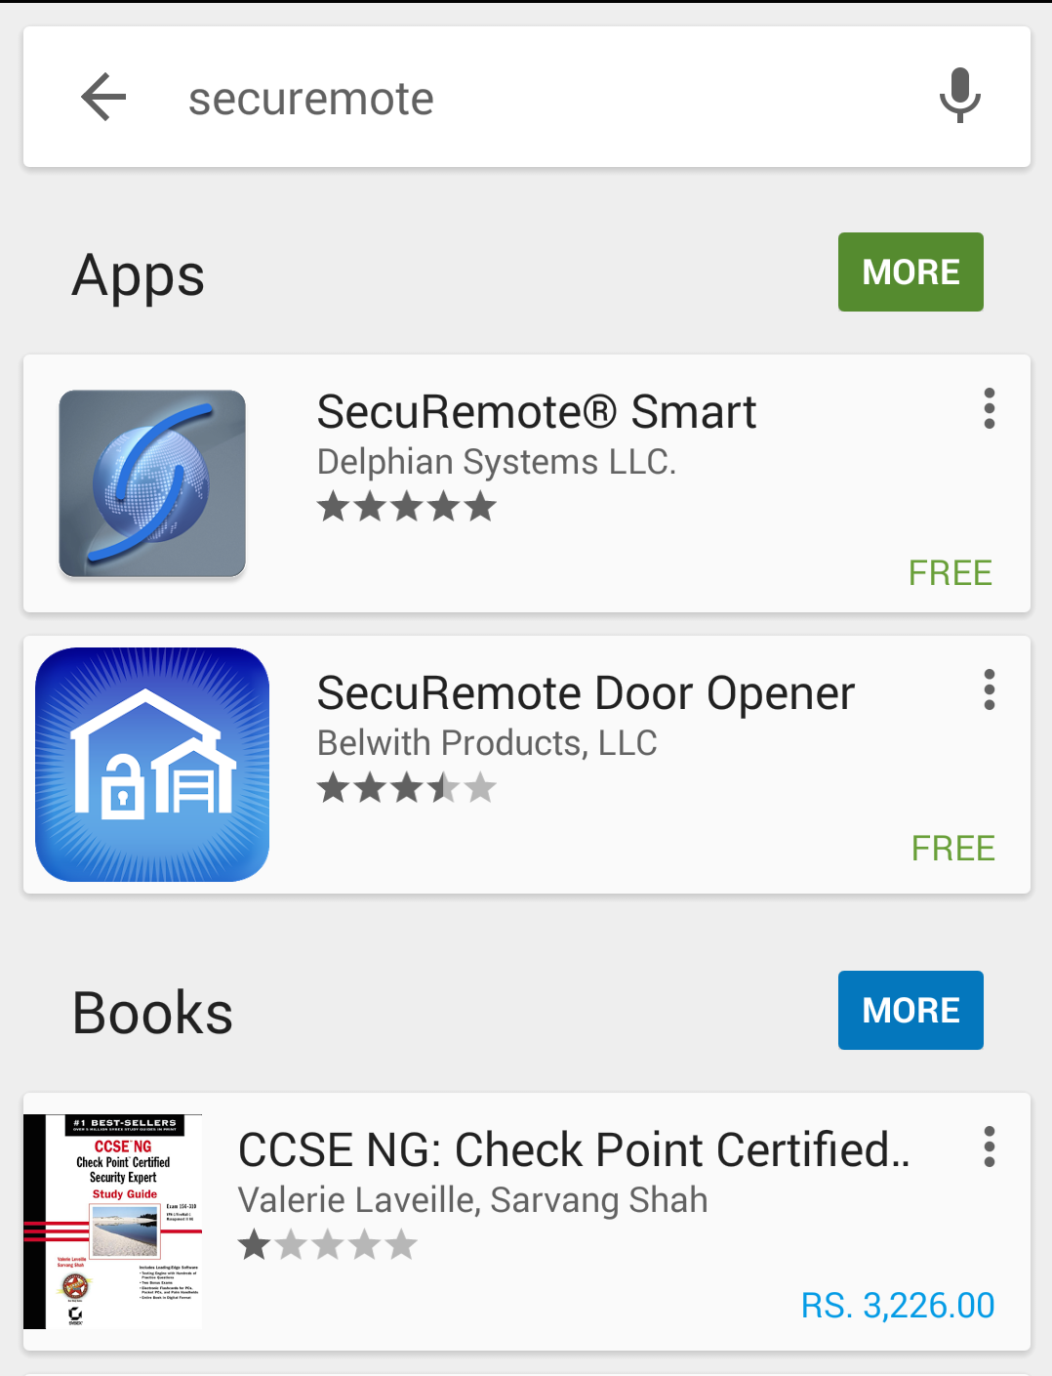

Smartphone Home Screen Search for SR Smart App App store search Screen

1. Click on “INSTALL”, to start installation of SR application.
2. By default, the “SR Smart” App icon is placed in the first available spot on your home screen.

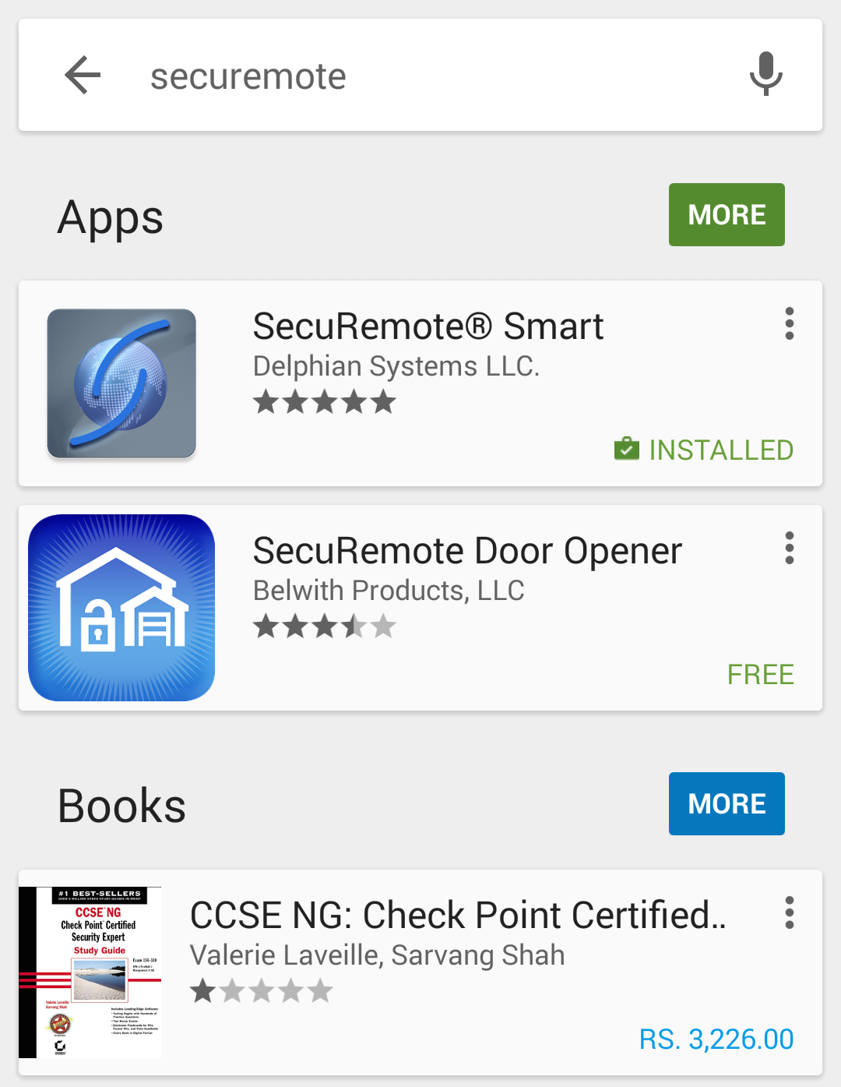 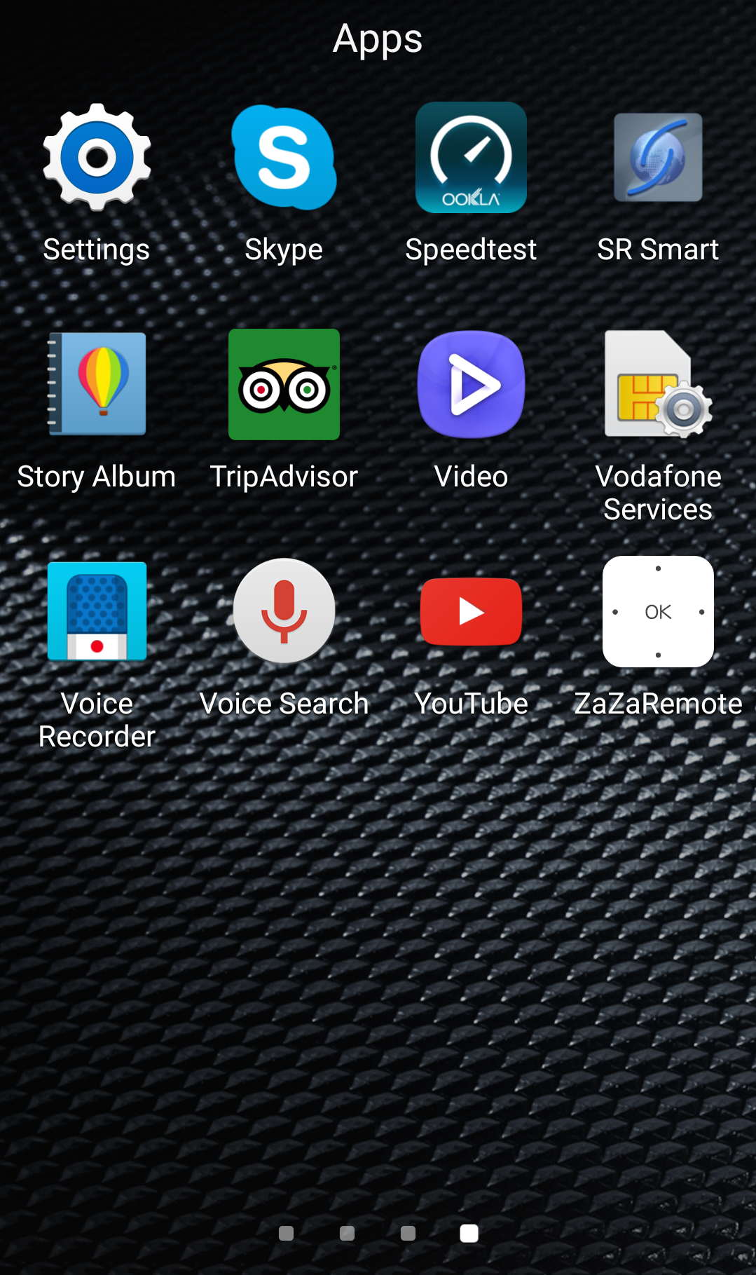

Install SR Smart App Installation Completed

# Register and Operate SR Devkit

After successful installation of “SR Smart” app, SR Smart app icon will appear on smartphone home screen. User can register SR device using “SCAN QR CODE” or “Enter SR # manually” options, upon successful activation user can pair and operate SR Devkit

***Note:*** Turn on data services and Bluetooth service before accessing the app store.

## Register Device using Scan “QR Code”

1. Click on the “SR Smart” app icon to launch the SR Smart app. “ADD SR DEVICE” screen will open.
2. Click on “SCAN QR CODE” option to add device, “Scan QR Code” will launch Camera to scan SR # from user manual or on the Devkit.
3. After QR Code is scanned successfully, SR Device information fills in automatically in “ADD SR DEVICE” screen. Enter “SR Device Name” and click on “Create New Account” option.

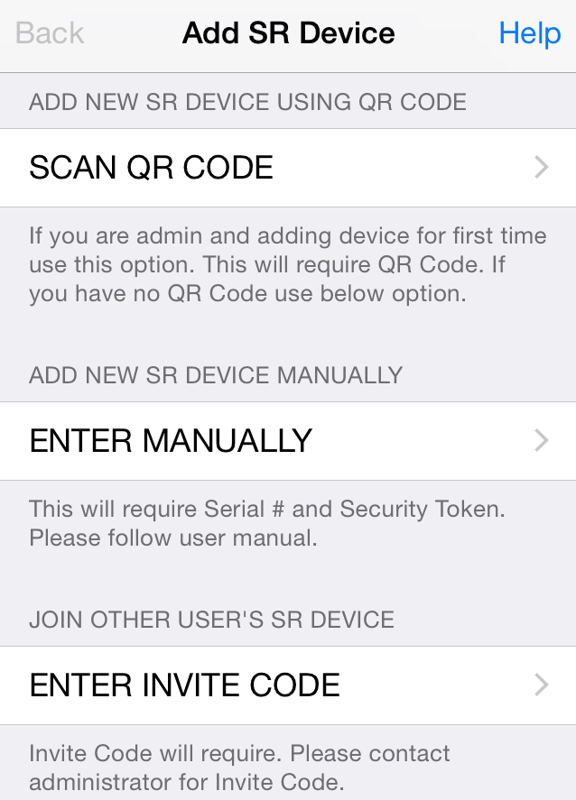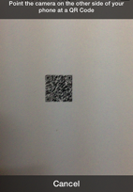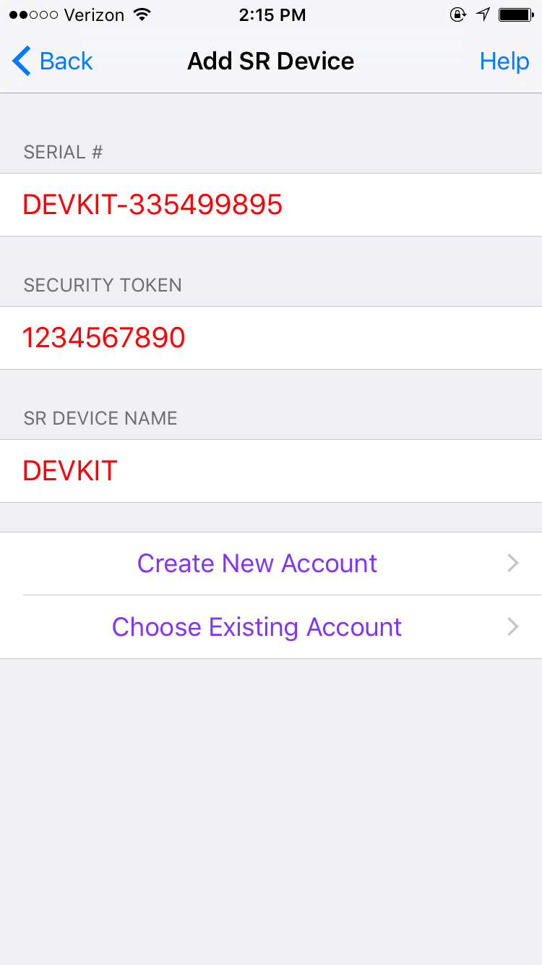

Add SR Device  Scan QR Code  Add SR Device

1. Enter all mandatory information in “Create SR Account” screen and click on “Register SR Device” option.
2. It will display “Registering SR Device” activity message in “Create SR Account” screen.
3. After device is registered on server it will redirect to app home screen and display “Garage is paired successfully, you can start operate it.” Toast message.

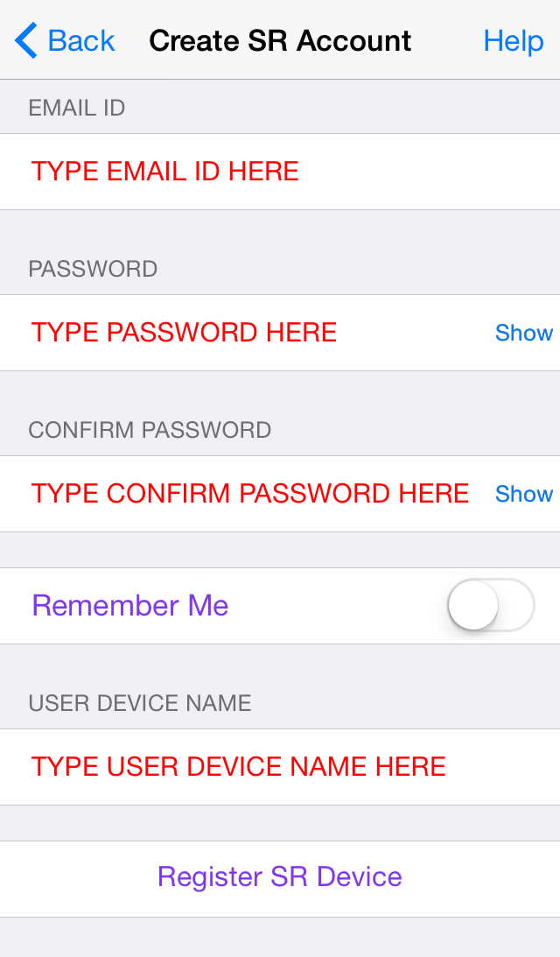 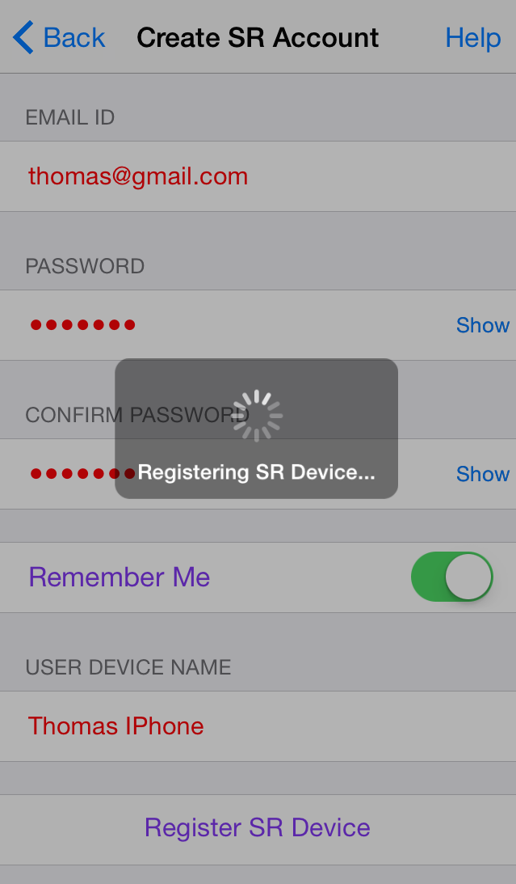 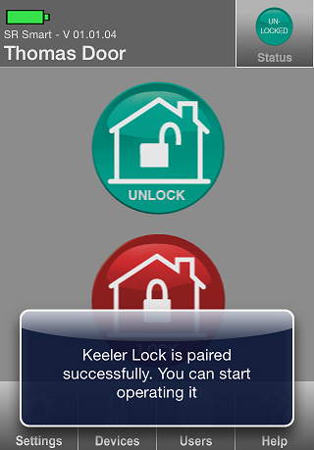

Create SR Account Registering SR Device Home Screen

## Register Device manually

1. Click on the “SR Smart” app icon to launch the SR Smart app. “ADD SR DEVICE” screen will open, Click on “Enter MANUALLY” option to add device manually.
2. It will display “ADD SR DEVICE” screen.
3. Enter all require SR Device information and click on “Create New Account” or “Choose Existing Account” option to add SR Device information.

 

Add SR Device  Add SR Device

1. It will display “Create SR Account” screen.
2. Enter all require SR Account details and click on “Registering SR Device” option, it will appear “Registering SR Device” activation message.
3. After device is registered on server it will redirect to app home screen and display “Devkit is paired successfully. You can start operate it.” Toast message.

  

Create SR Account Registering SR Device  Home Screen

# Operate SR Devkit using SR Smart App

User can operate any devices from Devkit by selecting it from home screen.



**Home Screen**

## Operation Modes

User can select operation mode of device from the settings 🡪 SR Smart App Settings 🡪 Operation Mode

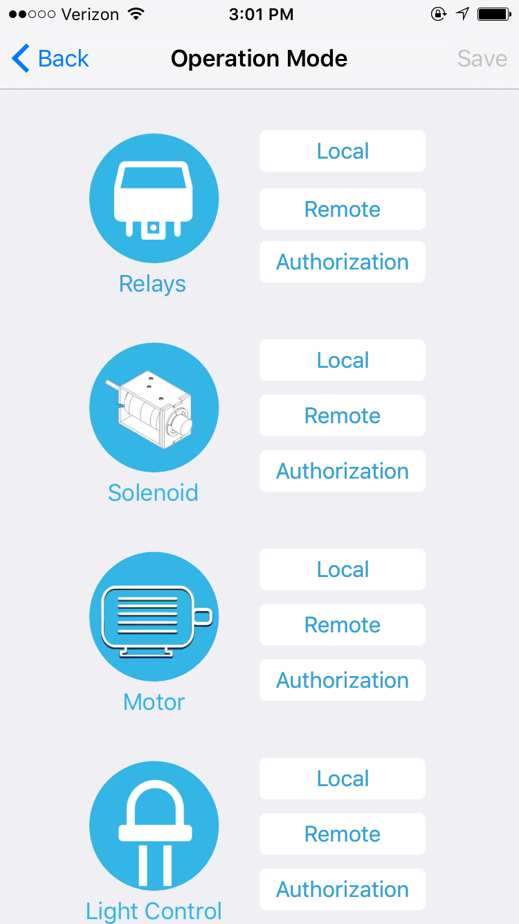

**Operation Mode**

### Local Operation Mode

Local operation mode offers user to operate device using Bluetooth. Using this mode user is authorized locally by SR Devkit.

### Remote Operation Mode

Remote mode offers user to operate SR Devkit from anywhere using internet. User authorization is done at server level. This mode requires SR Bridge.

### Authorization Mode

Authorization mode allows user to operate SR Devkit locally using Bluetooth but user is authorized by server. This mode requires internet connectivity in phone.

# Firmware Upgrade (OTA)

Devkit supports over the air firmware upgrade. It helps user to keep Devkit firmware with latest features. It is easy and one click process. Go to Settings🡪About SR Device🡪Firmware Upgrade

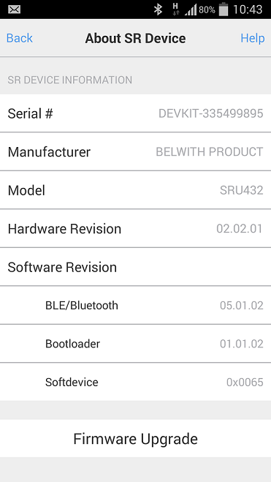

**Firmware Upgrade**

# SR Portal

SecuRemote® Online allows users to expand the capabilities of SecuRemote Smart™. This web-based user management and authorization system lets the SecuRemote Smart™ Administrator use a computer to remotely manage users and their access times/days, and to monitor door use. SecuRemote® Online brings more convenience, control and security to families.

## Sign-In Page

The e-mail address and password you used during registration are required to log-in to SecuRemote® Online. Your account must have been previously activated via the confirmation link sent to your e-mail.

You can choose to have your password reset by following the “Forgot your Password?” This requires you to know the e-mail address and last name used to register the account. An e-mail Message is then sent to you with a link that can be used to complete the password reset.

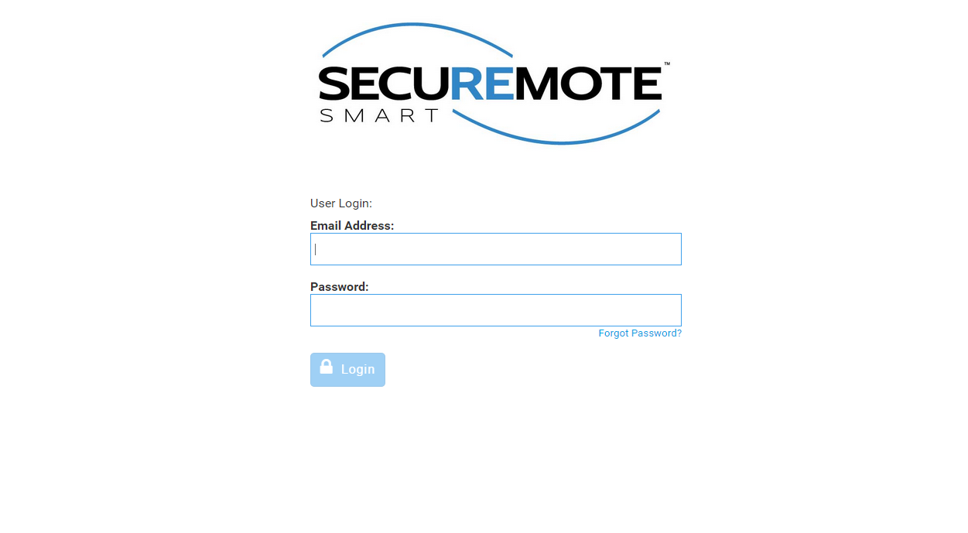

Sign In Page

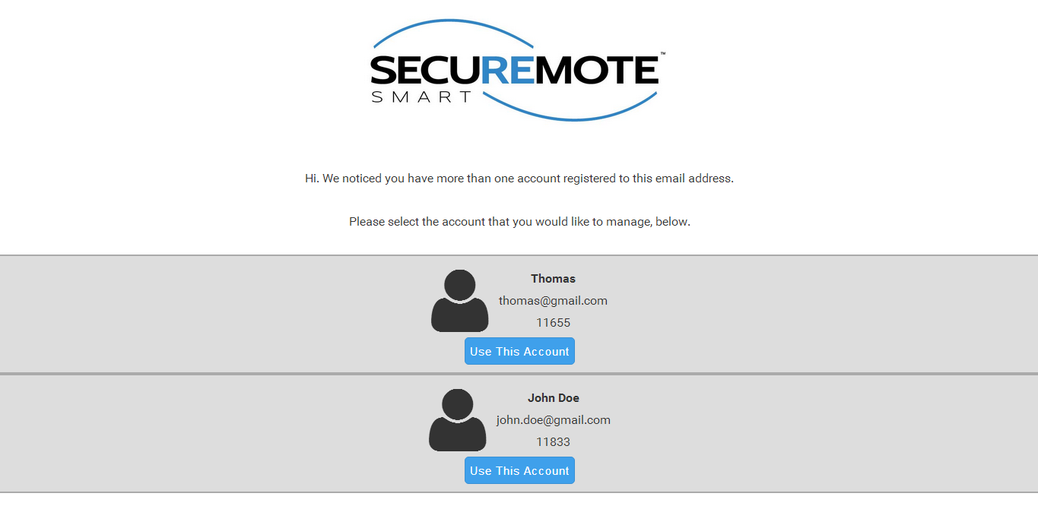

Sign In

## Secure Home Page

Dashboard page will display with recent activities and welcome message.

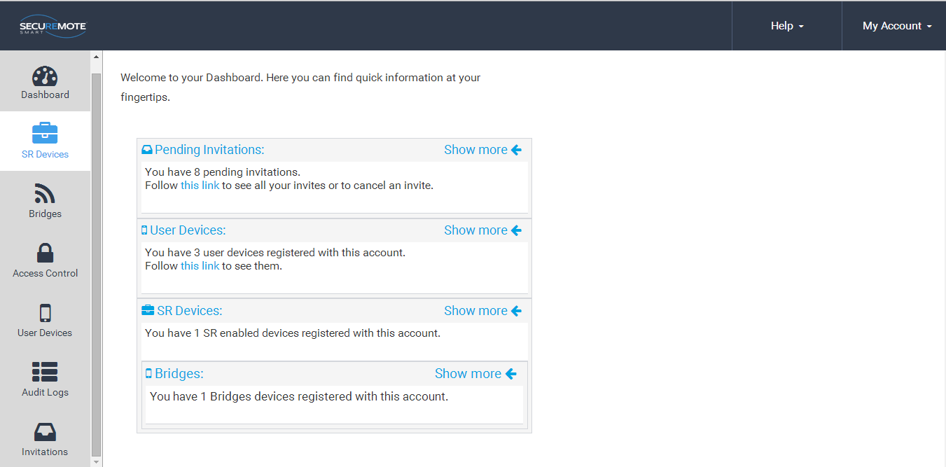

SecuRemote® Smart Home Page

## Add SR device

First user has to register the device from SecuRemote Smart™ Online site.

1. Select “SR Device” option and click on “Add SR Device”.

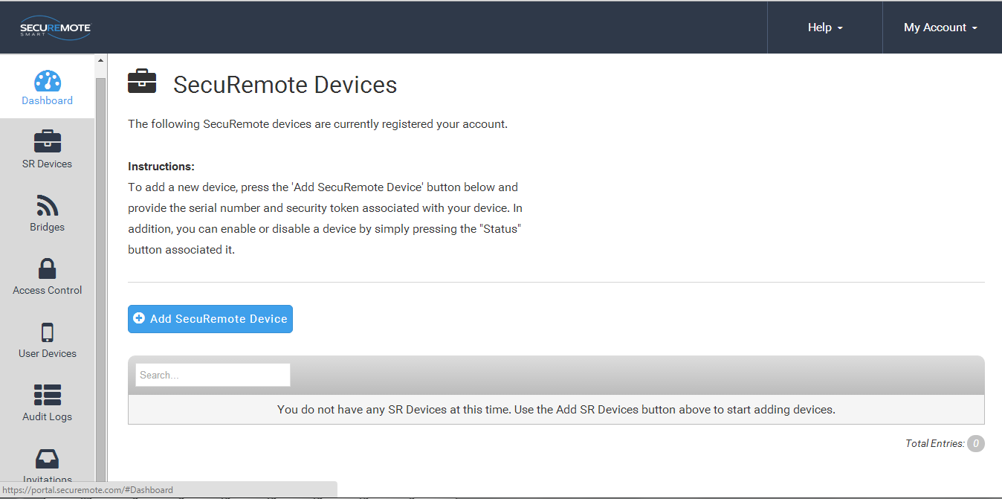

All devices

1. Requires entry of Serial number, Security token and Name of the SR Devkit and click on “Add SR Device”.

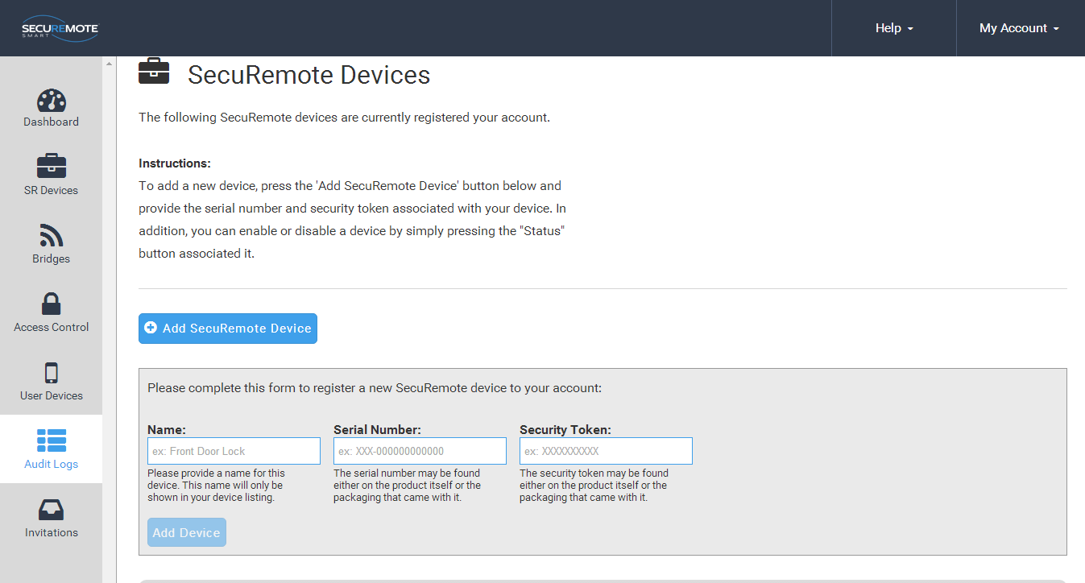

New device Registration

## All SR Devices

All devices belonging to the account are show in “SR Devices” screen.

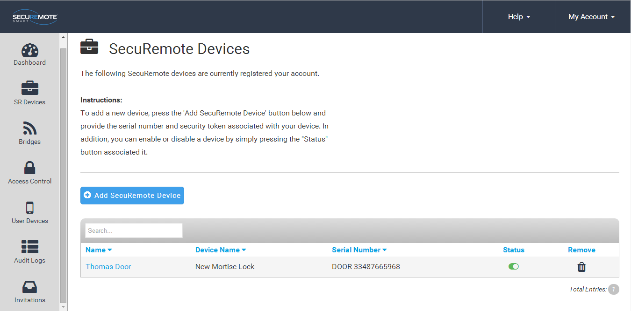

**All devices**

## Invite a New User Device

Enter user name in the “Name” field and Click on “Request Invite Code”. You cannot enter a user with a name that already exist.

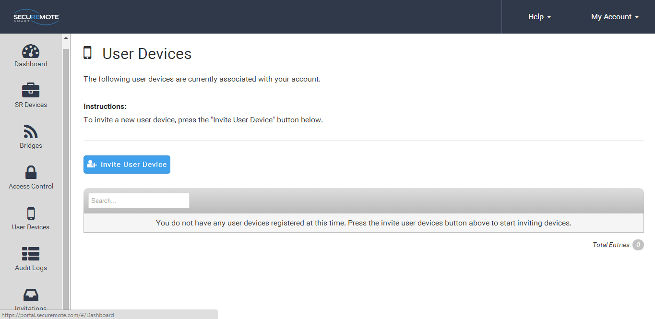

**Invite a New User**

New screen will show generated invited code and confirmation message will appear right hand bottom corner.

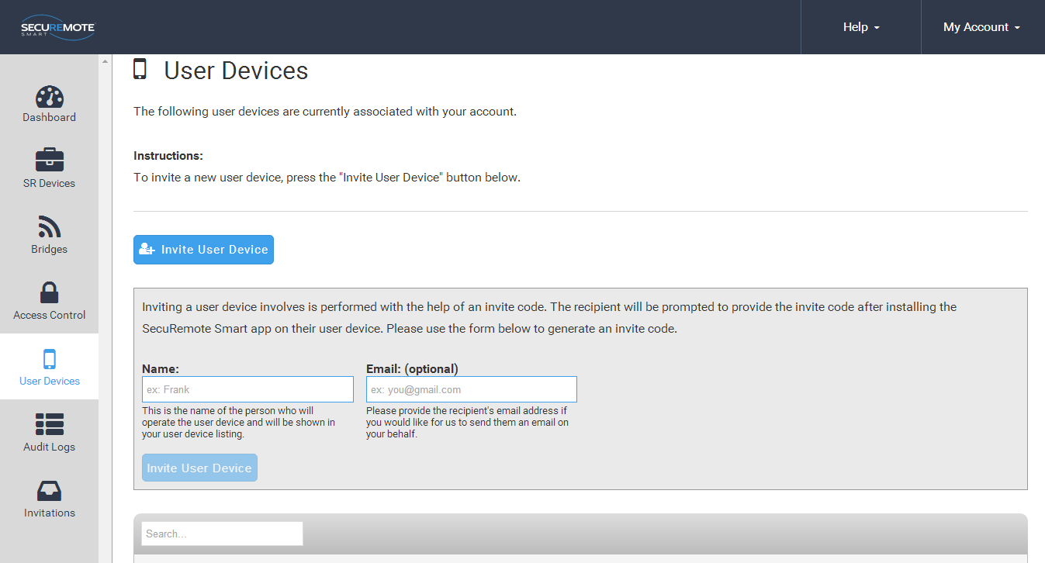

**User Invitation**

## All Users

1. The account administrator cannot be removed from the account.
2. Clicking on the user’s name brings up the “Edit user” dialog.
3. Security Link is an advanced security feature that allows the SecuRemote® Online service to uniquely identify a user’s smartphone. When a SecuRemote Smart™ app is run for the first time it generates a unique security token, a large random number that it sends to SecuRemote® Online every time an authorization request is made. This token must match the one used on previous requests in order for the request to be authorized. This ensures that no other smartphone can be used to initiate an authorization request on behalf of that user.

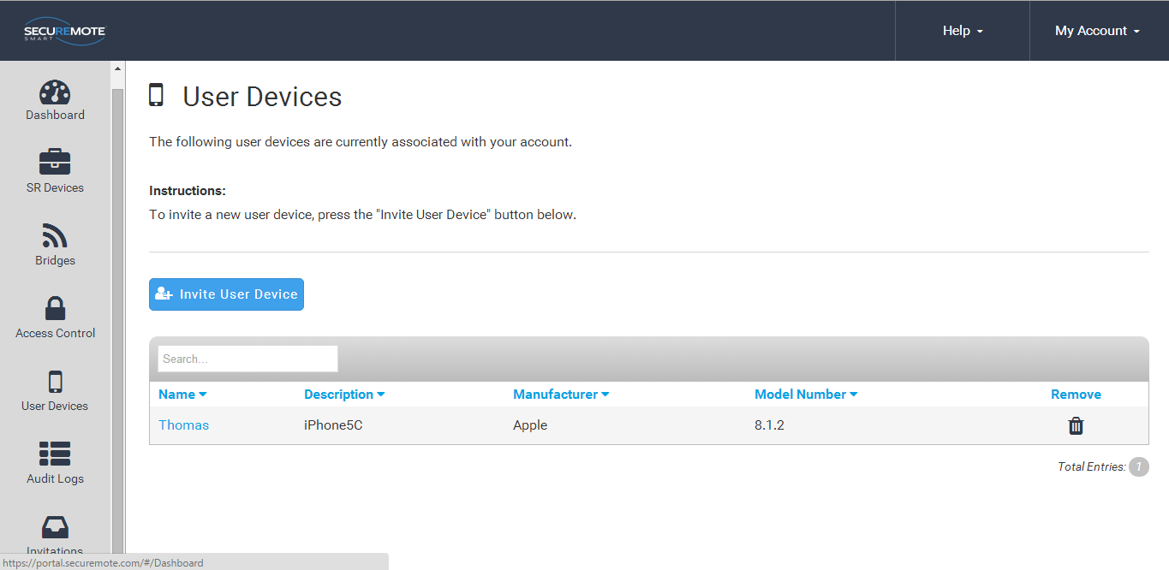

**All Users**

## Audit Logs

* 1. Audit log entries are shown in UTC by default on all accounts since it’s possible that they have multiple devices in different time zones.
  2. Audit logs are maintained for 365 days, the maximum length, by default for each account. The user can reduce this to as little as 7.
  3. Downloading the logs in Excel, CSV or XML format will download the entire audit log history. It is not affected by the filters used on the table above.

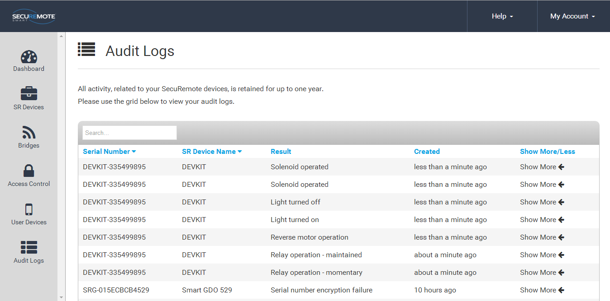**Audit Logs**

## Register SR Bridge

Enter valid Serial number and click on Register SR Bridge.

Before registering the bridge user has to make sure bridge is powered on. It has to be connected with router through RJ 45 LAN cable in case Ethernet Bridge.

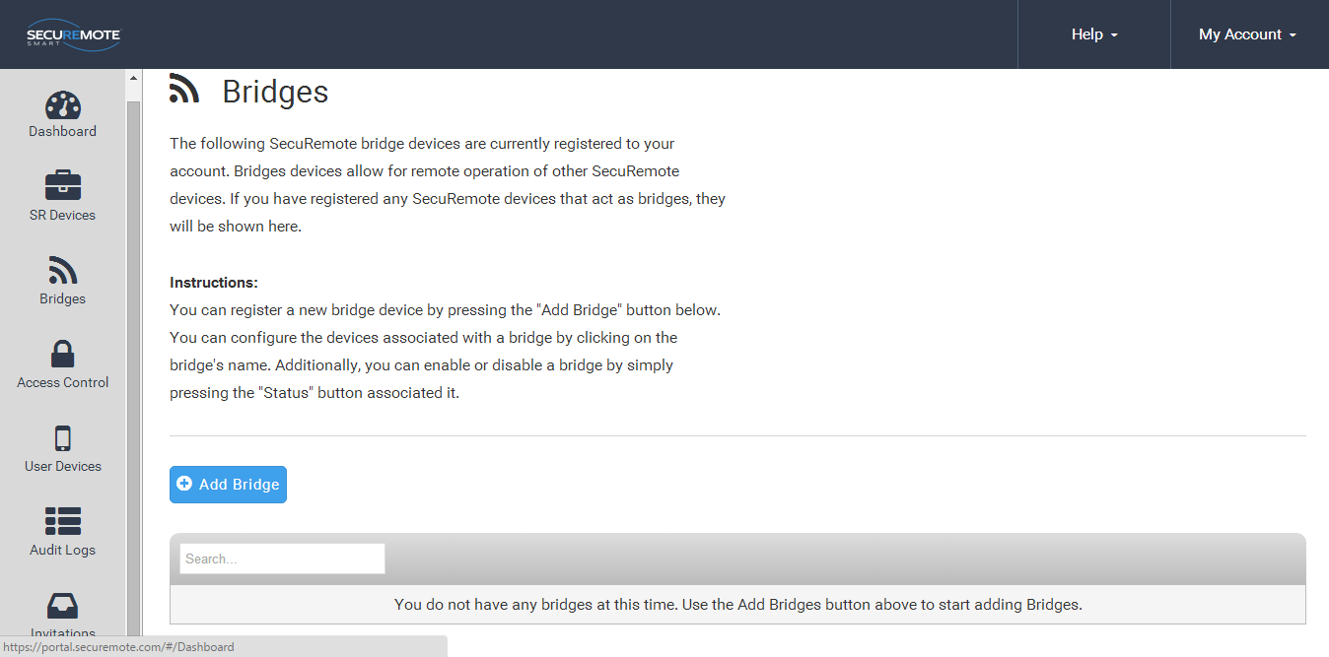

**New SR Bridge Registration**

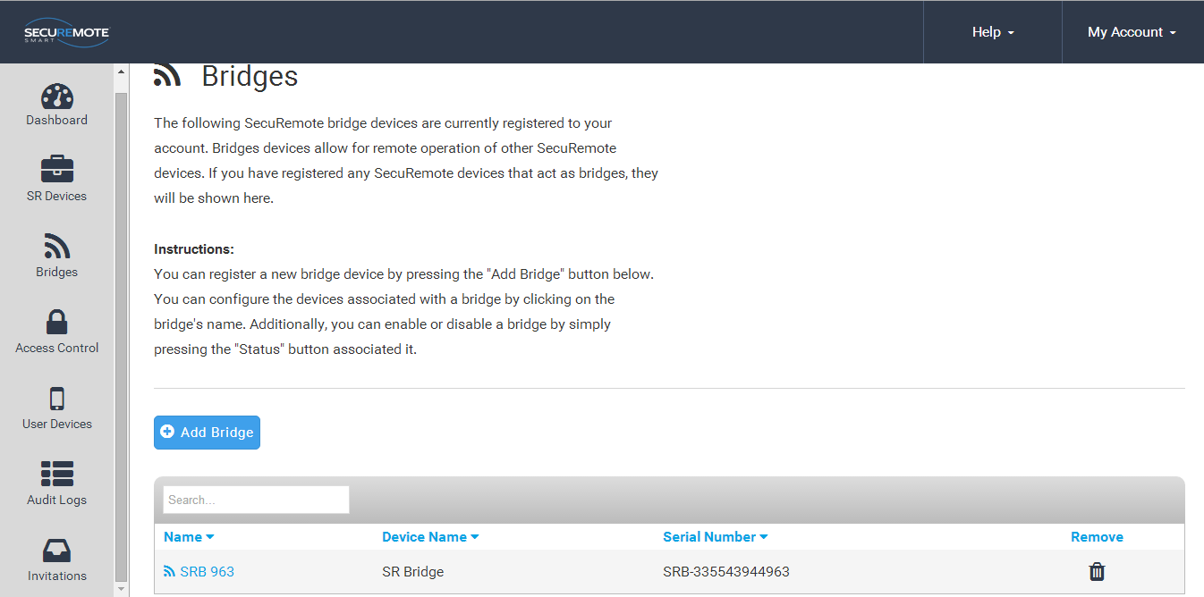

**New SR Bridge Registration**

## Configure SR Bridge

Click on SR Bridge Name to assign SR Bridge to SR Devkit.

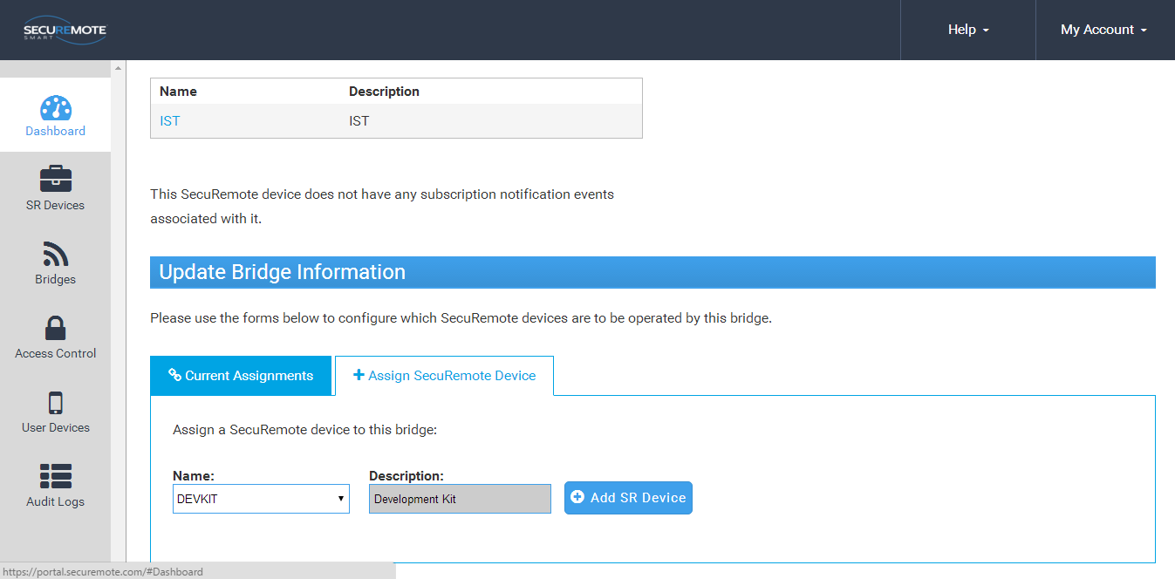

**Assign SR Device**

Please click on “Add SR Device” button which you want to Configure and confirm.

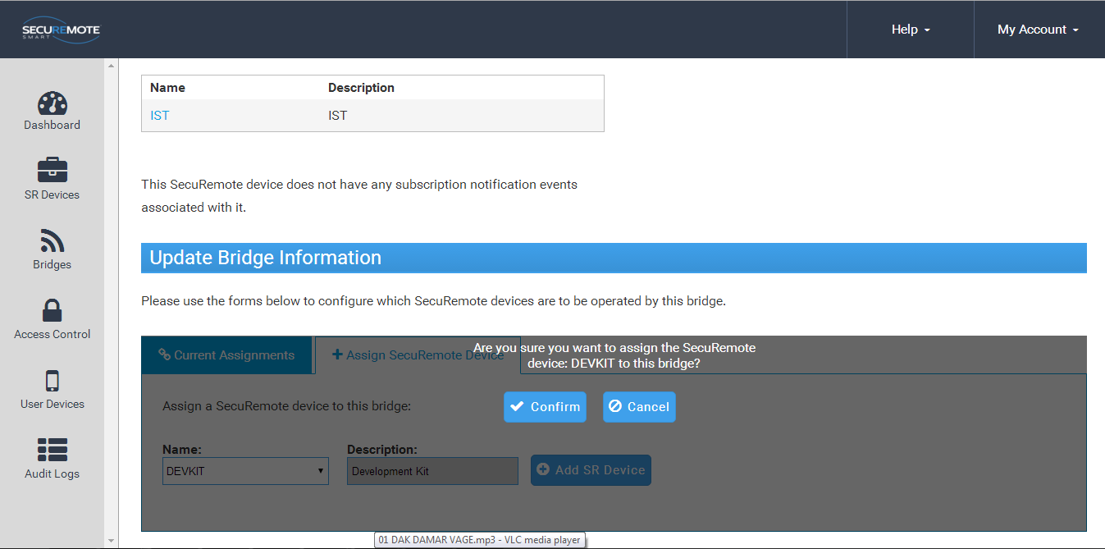

**Manage SR Devkit**

Selected device’s name will show in Current Assignments list.

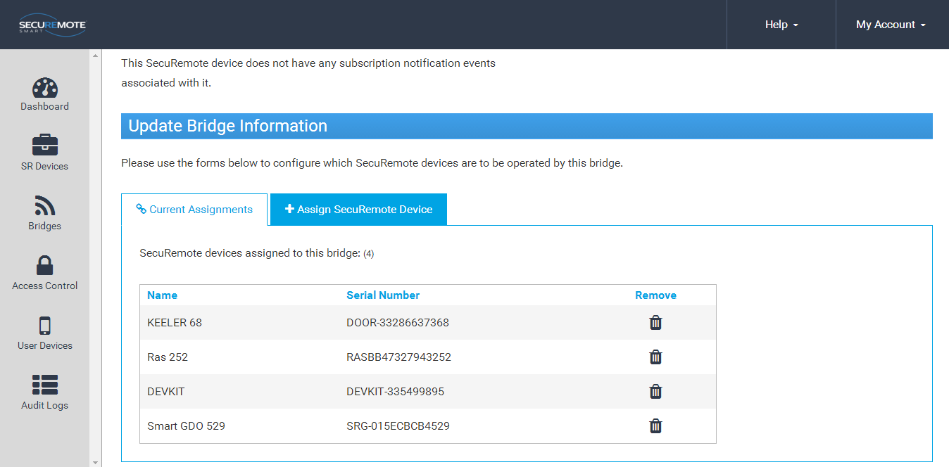

**Manage SR Devkit**

## Dashboard Option

This screen shows recent activities.

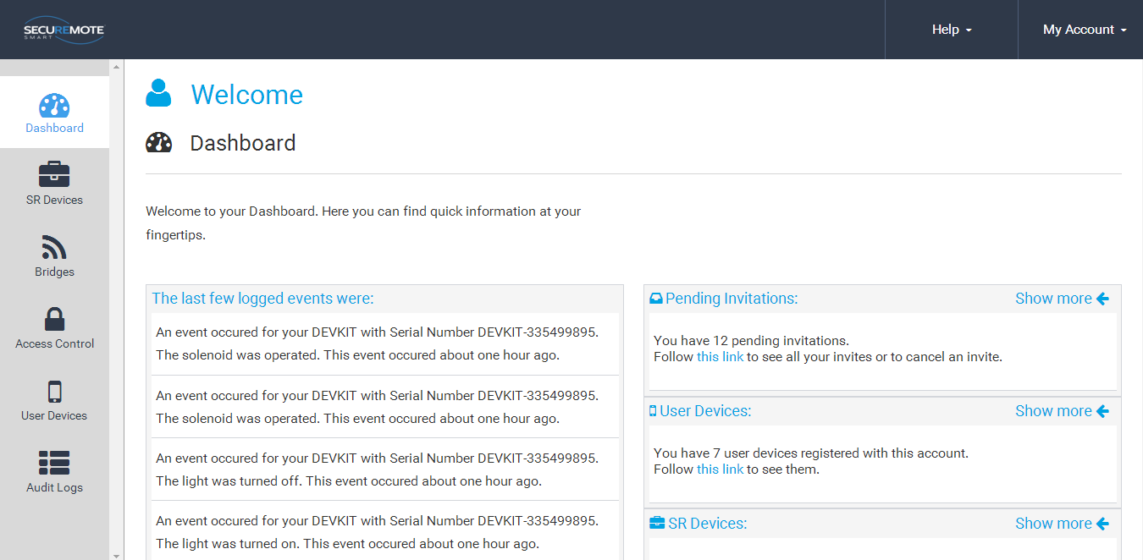

**Dashboard**

## **Invites Option**

This screen shows invitation send by users.

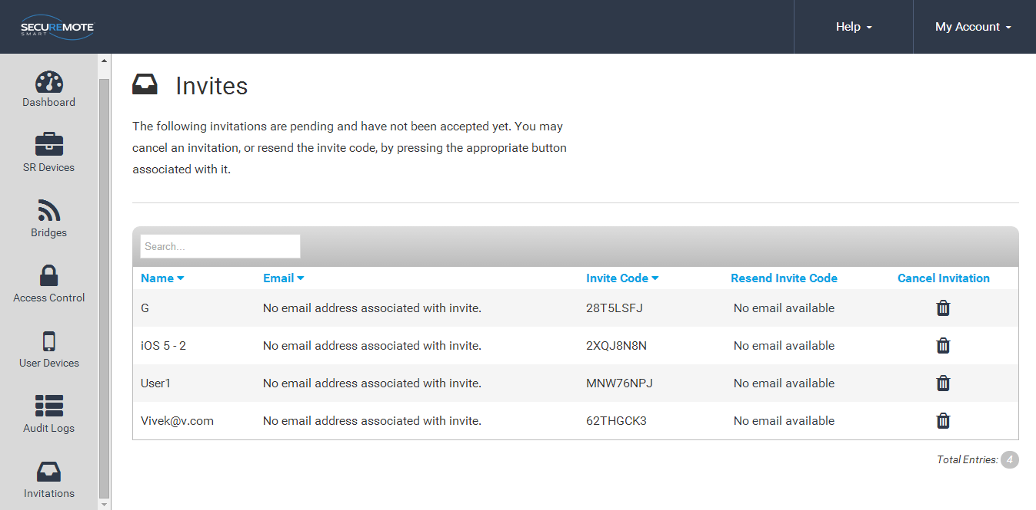

**Invite Screen**

## Enable Push Notification

Push notification feature allows you to be notified when SR Devkit is operated.

Go to Notifications 🡪 Create New Notification 🡪 Choose an SR Device 🡪 Select events to subscribe 🡪 Choose a User Device you want the notifications to go to.

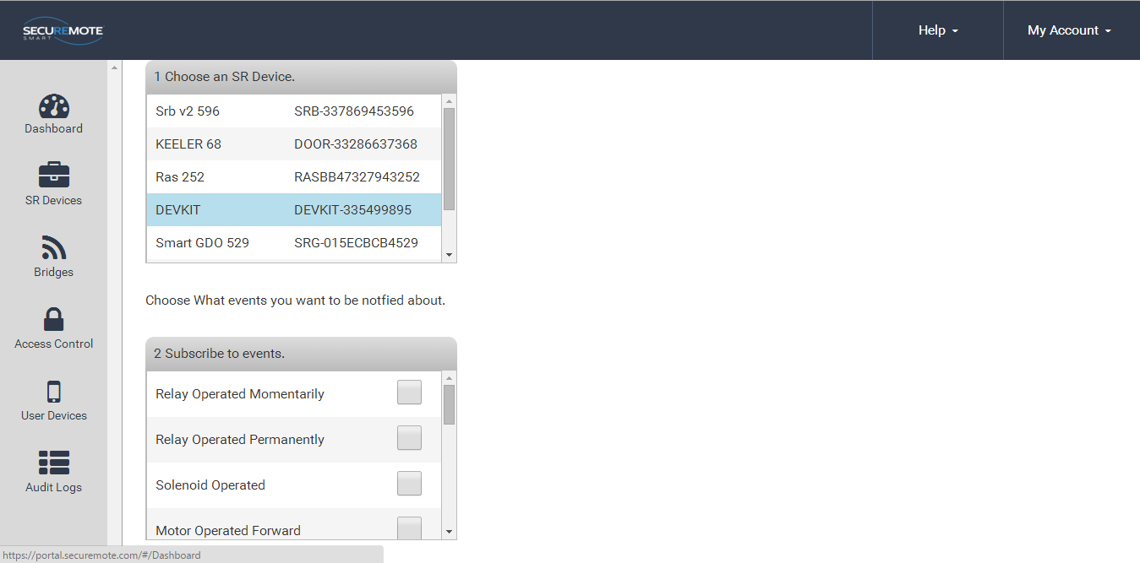

**Push Notification**

# Jumper Details

|  |  |  |
| --- | --- | --- |
| **Jumper** | **Pin#** | **Description** |
| JP1 | Pin #1 and Pin#2 should be shorted or pin #3 and# 4 should be shorted. Arrow marked side of jp1 should be considered as Pin# 1. | This pin configuration will give on board power supply for the LED fixture. |
| JP2 | Pin #1 and Pin#2 should be shorted or pin #3 and# 4 should be shorted. Arrow marked side of jp1 should be considered as Pin# 1. | This pin configuration will give on board power supply for the LED fixture. |
| JP3 | Connect jumper on Pin#2 and pin#3 for temperature interface control**.** | JP3 jumper will select Temperature interface. |
| JP5 | Connect jumper on Pin#1 and pin#2 for external analog interface 2. | If this jumper used then no need to give any jumper selection on JP3 and user can use external analog interface 2. |
| JP6 | 1. Connect jumper on Pin#1 and pin#2 for ADC#1 (Water sensor) 2. Connect jumper on pin#2 and pin#3 for external analog interface 1. | Connect jumper on pin #1 and pin#2 for water sensor interface selection  Or pin#2 and pin#3 for external analog interface 1. |

**Jumper setting**

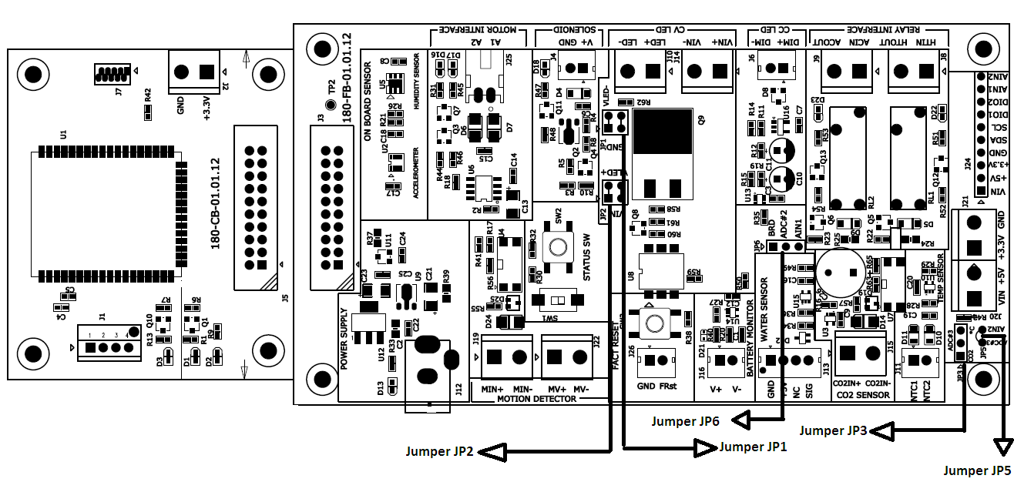

# LED Indication Detail (All LED’s are Pre-Configured)

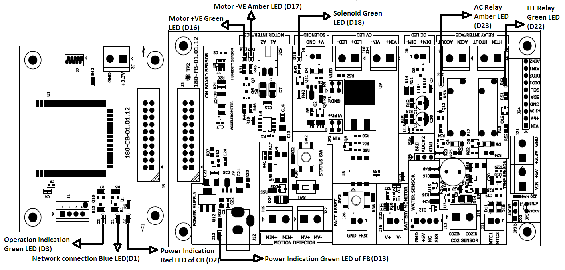

**LED Indication detail**

-For operation indication GREEN LED (D3), Network indication BLUE LED (D1) and power indication (D2) shown in Communication Board.

- Below table shows the sensor devices and its LED indication when connected with application and in operation mode.

- Blue LED (D1) on CB board will indicate the status of network connection.

|  |  |  |  |
| --- | --- | --- | --- |
| **Sensor Devices attached with Dev kit** | **LED indication in Dev Kit** | | |
| Blue | Green | Amber |
| Solenoid (D18) | Yes (D1) | Yes (D18) | No |
| Motor +Ve(D16) | Yes (D1) | Yes (D16) | No |
| Motor –Ve(D17) | Yes (D1) | No | Yes (D17) |
| Relay 1(Heater)(D22) | Yes (D1) | Yes (D22) | no |
| Relay2(AC)(D23) | Yes (D1) | No | Yes (D23) |
| Temperature | Yes (D1) | No | No |
| Motion | Yes (D1) | No | No |
| Constant voltage  LED support | Yes (D1) | No | No |
| Constant current  LED support | Yes (D1) | No | No |
| Status switch | Yes (D1) | No | No |
| Factory Reset switch | Yes (D1) | No | No |

# Accessory details connected to dev kit

|  |  |  |  |  |
| --- | --- | --- | --- | --- |
| Sr. # | Peripheral name | Specification | Suggested DigiKey part# | Other Vendor detail |
| 1 | Motion Sensor | Voltage input : 12VDC, Voltage Output:12 VDC | - | Nanyang senba, Item # : SB00612A-02 |
| 2 | Solenoid | Operating Voltage: 12VDC, Coil resistance 36 ohm | [527-1000-ND](http://www.digikey.com/product-detail/en/F0411A/527-1000-ND/668285) | 1. Manufacturer : [JAMECO RELIAPRO](http://www.jameco.com/webapp/wcs/stores/servlet/StoreCatalogDrillDownView?langId=-1&storeId=10001&catalogId=10001&refineType=String&sub_attr_name=Manufacturer&refineValue=JAMECO%20RELIAPRO&from=mflisting)   Manufacturer Part#: [SMO-0837S12STD-R](http://www.jameco.com/webapp/wcs/stores/servlet/Product_10001_10001_262272_-1) |
| 3 | Motor | 12VDC | - | RAS 1.5 project |
| 4 | Battery | 1.5V to 12 VDC | ANY | ANY |

# GPIO Information for Interface

|  |  |  |  |
| --- | --- | --- | --- |
| Sr. # | Signal Name | GPIO pin in NS-BLE Module | GPIO pin in A BLE Module |
|  | Motor Interface (Motor +VE) | P0.14 | P0.03 (F3) |
|  | Motor Interface (Motor -VE) | P0.10 | P0.02 (F5) |
|  | Solenoid Interface | P0.13 | P0.13 (C2) |
|  | Relay1 control interface | P0.12 | P0.12 (D1) |
|  | Relay2 control interface | P0.08 | P0.08 (F1) |
|  | Status switch 1 (Status_SW1) | P0.28 | P0.30 (E6) |
|  | Status switch 2 (Status_SW2) | P0.29 | P0.31 (F6) |
|  | Factory Reset switch (FACT_RESET) | P0.15 | P015 (D2) |
|  | Water Sensor (ADC#2) | P0.06/AIN7 | P0.06 (E3) |
|  | Temp. sensor interface (ADC#3) | P0.04/AIN5 | P0.04 (E4) |
|  | Constant current LED support (PWM_IN) | P0.23 | P0.23 (D4) |
|  | Constant voltage LED support (PWM_IN) | P0.23 | P0.23 (D4) |
|  | Humidity Sensor (I2C-SCL) | P0.20 | P0.20 (B3) |
|  | Humidity Sensor (I2C-SDA) | P0.11 | P0.11 (E2) |
|  | Accelerometers (INT_ACC) | P0.16 | P0.16 (C3) |
|  | Battery Voltage monitoring(ADC#1) | P0.05 | P0.05 (F2) |
|  | Status LED Green | P0.24 | P0.24 (D6) |
|  | Status LED Blue | P0.25 | P0.25 (D3) |
|  | UART-RX | P0.18 | P0.18 (B2) |
|  | UART-TX | P0.17 | P0.21 (D5) |

# Disclaimers /Contacts/FCC

Products, claims in this kit are accurate as possible at time of printing. Developer kit is subject to change. Belwith and Delphian are wholly owned by JVA Partners.

Contact information: Delphian Systems LLC, 720 Dartmouth Lane, Buffalo Grove, IL 600089. USA. Phone 847-419-7980. Products and devices shown are copyrighted and have US and foreign patents pending.

All rights reserved. Trademarks shown are held by their respective owners.

SecuRemote ™ is trademark by Belwith Products LLC.

For indoor use ONLY. Caution! Any changes or modifications to this module not approved by Belwith Products LLC could void the authority to operate this module.

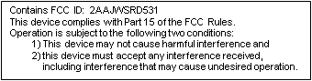

To satisfy RF exposure requirements, this device and its antenna must operate with a separation distance of at least 20 cm from all persons and must not be co-located or operating in conjunction with any other antenna or transmitter.

This equipment has been tested and found to comply with the limits for a class B digital device,

pursuant to part 15 of the FCC rules. These limits are designed to provide reasonable protection

against harmful interference in a residential installation. This equipment generates, uses a can

Radiate radio frequency energy and if not installed and used in accordance with the instructions,

may cause harmful interference to radio communications. However, there is no guarantee that

Interference will not occur in a particular installation. If this equipment does cause harmful

interference to radio or television reception, which can be determined by turning the equipment

off and on, the user is encouraged to try to correct the interference by one or more of the

Following measures:

* Reorient or relocate the receiving antenna.
* Increase the separation between the equipment and the receiver.
* Connect the equipment into an outlet on a circuit different from that to which the receiver is connected.
* Consult the dealer or an experienced radio/TV technician for help.

In order to maintain compliance with FCC regulations, shielded cables must be used with this equipment. Operation with non-approved equipment or unshielded cables is likely to result in interference to radio and TV reception. The user is cautioned that changes and modifications made to the equipment without the approval of manufacturer could void the user’s authority to operate this equipment.

# Electric Characteristics

|  |  |  |  |  |  |  |
| --- | --- | --- | --- | --- | --- | --- |
| Sr. # | I/O Name | Wire color code | Description | Specification | Protection | UL details |
| 1 | Motor+ |  | +VE connection for Motor interface | Voltage Load : 12VDC | BA6287F has built-in surge absorption diode | - |
| Motor – |  | -VE connection for Motor interface |
| 2 | 1# of J4 Connector |  | +VE connection for Solenoid interface | Supply Voltage : 12VDC, Solenoid coil resistance 36 ohm |  | UL  Flammability Classification Rating 94V-0 (1N4148W-7-F) |
| 2# of J4 Connector |  | -VE connection for Solenoid interface |  |
| 3 | 1# of J8 Connector |  | HEATER1 pin of Thermostat control interface | Coil Voltage :12VDC, Contact Rating :5A, Switching Voltage :24 VDC |  | UL recognized / CSA certified. VDE Approved. (RL1 :- G5T-1A DC12) |
| 2# of J8 Connector |  | HEATER2 pin of Thermostat control interface |  |
| 4 | 1# of J9 Connector |  | AC1 pin of Thermostat control interface | Coil Voltage :12 VDC, Contact Rating :5A, Switching Voltage :24 VDC |  | UL recognized / CSA certified. VDE Approved. (RL2 :- G5T-1A DC12) |
| 2# of J9 Connector |  | AC2 pin of Thermostat control interface |  |
| 5 | Constant Current LED support (DIMMEROUT) |  | DIMMEROUT is connected to +Dim of constant current dimmer supply | 0 to 10 VDC @86 mA |  |  |
| 6 | Constant Voltage LED Support (LED+) |  | Driver voltage for LED | 12VDC @1A |  |  |